**Salesforce Tasks Examples**

**Name: Mriganka Patra**

**Emp No. 2415820**

1. **Validation Rules**
   1. Ensure Student’s Email matches a certain pattern (e.g. Must end with .com or .org)
   2. 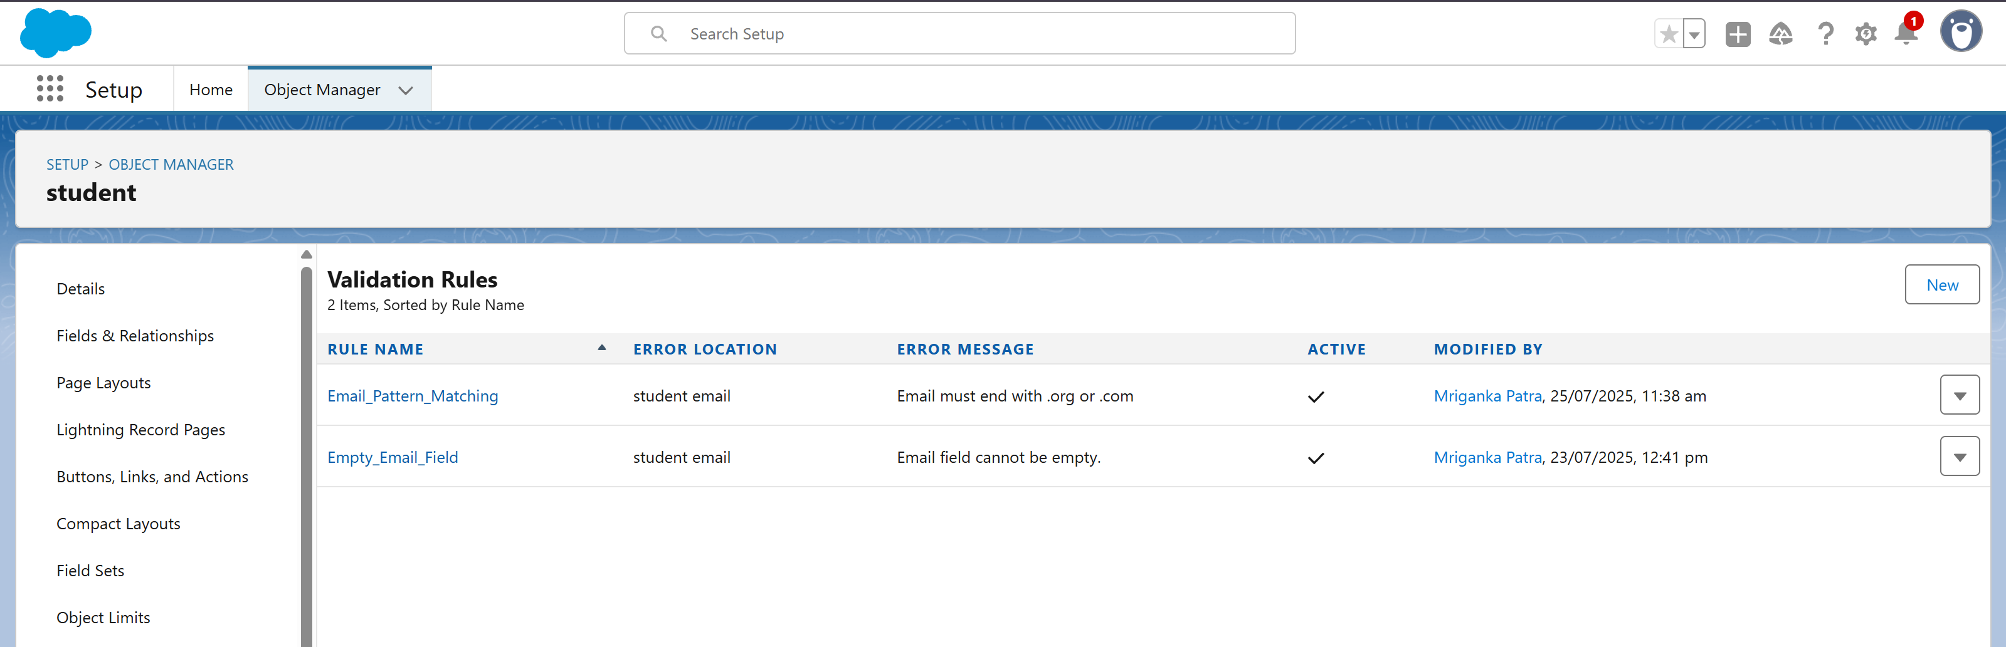
   4. 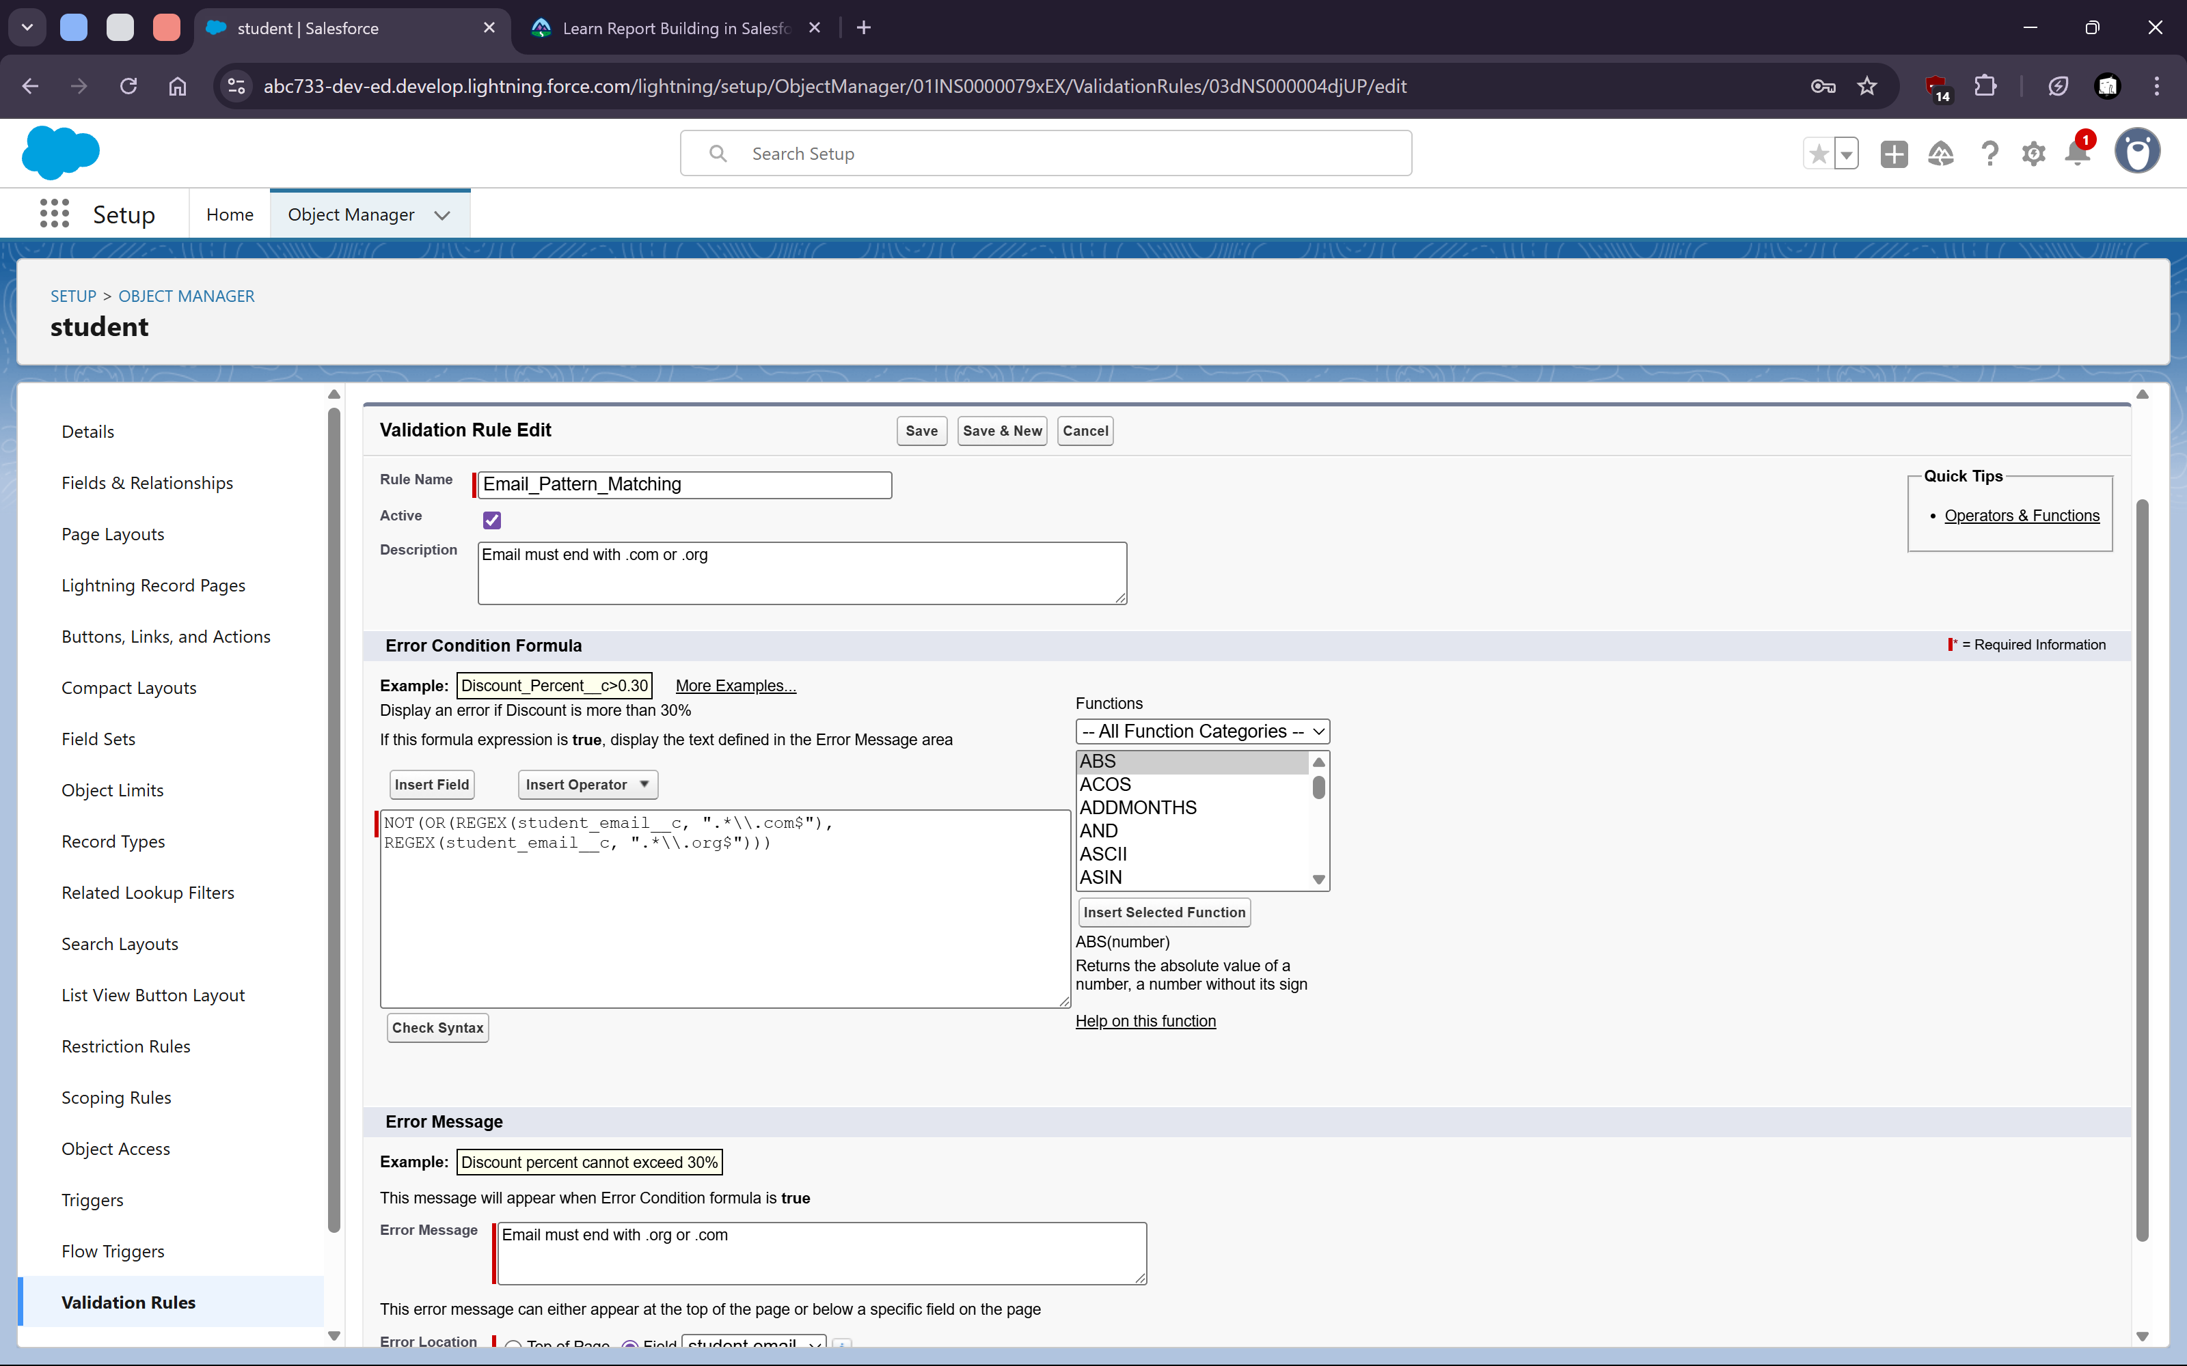




   10. Prevent changing stage once it reaches “Closed Lost”
   11. 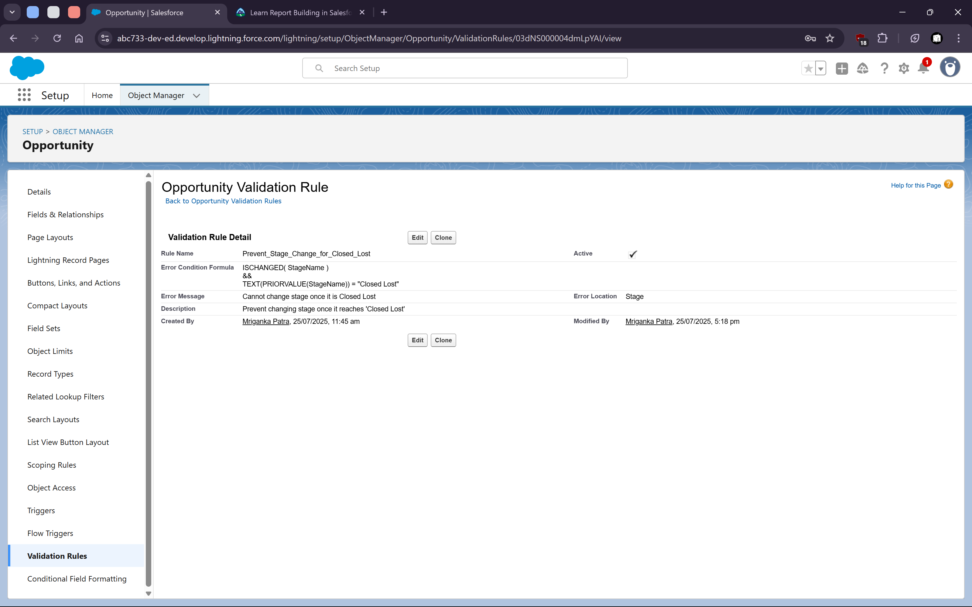
   13. Ensure that a Contact’s birthdate is not in the future
   14. 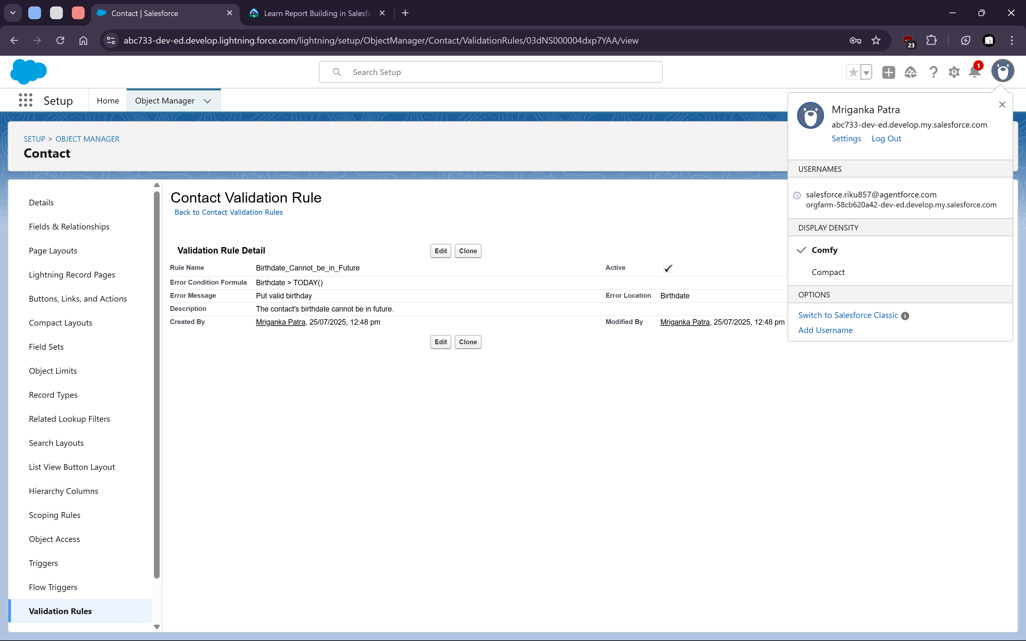
2. **Flows**
   1. On creation of a contact if email is not blank set “Clean Status” as “Reviewed”
   2. 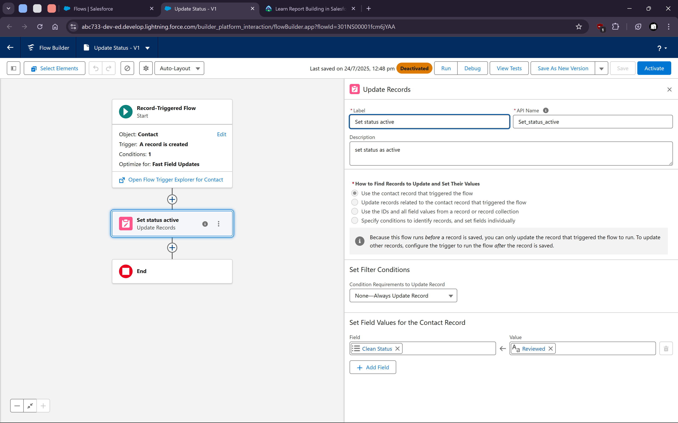
   4. When account is created or updated, if the Industry is “Education” set Type as “Prospect”
   5. 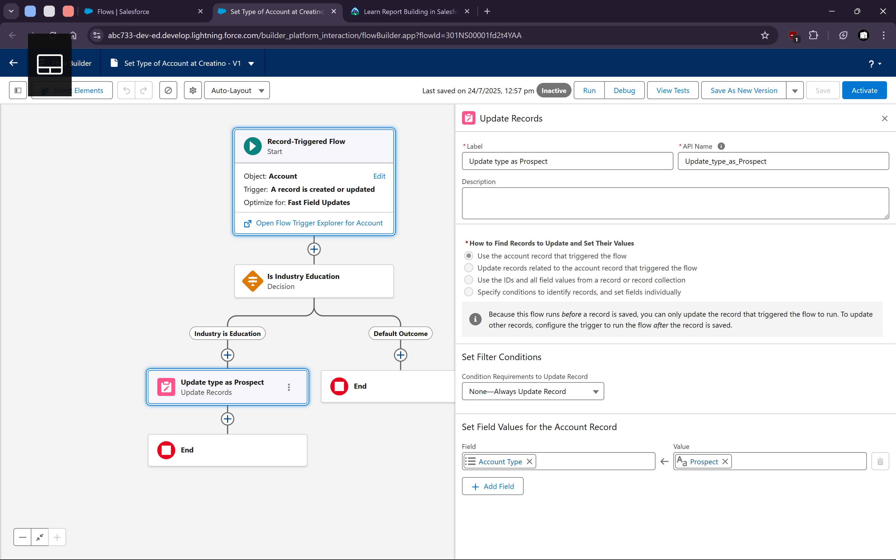
   7. When contact is created, is contact’s account is filled then map Account’s email to contact’s email.
   8. 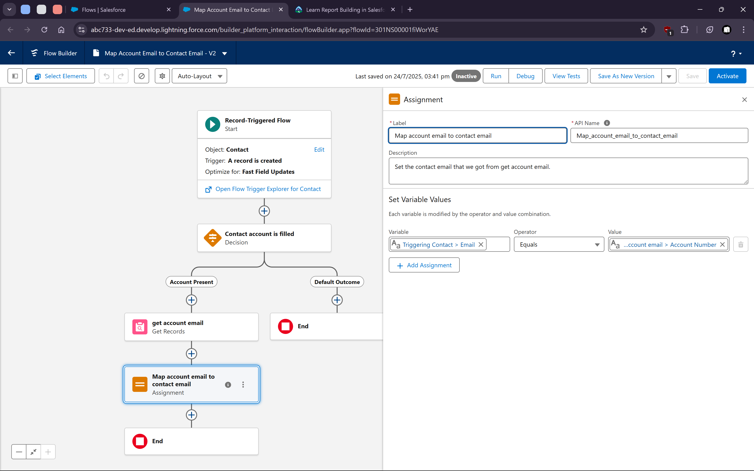
3. **Security**
   1. For custom object “Student” manage field level permissions for the profile “System Administrator”
   2. 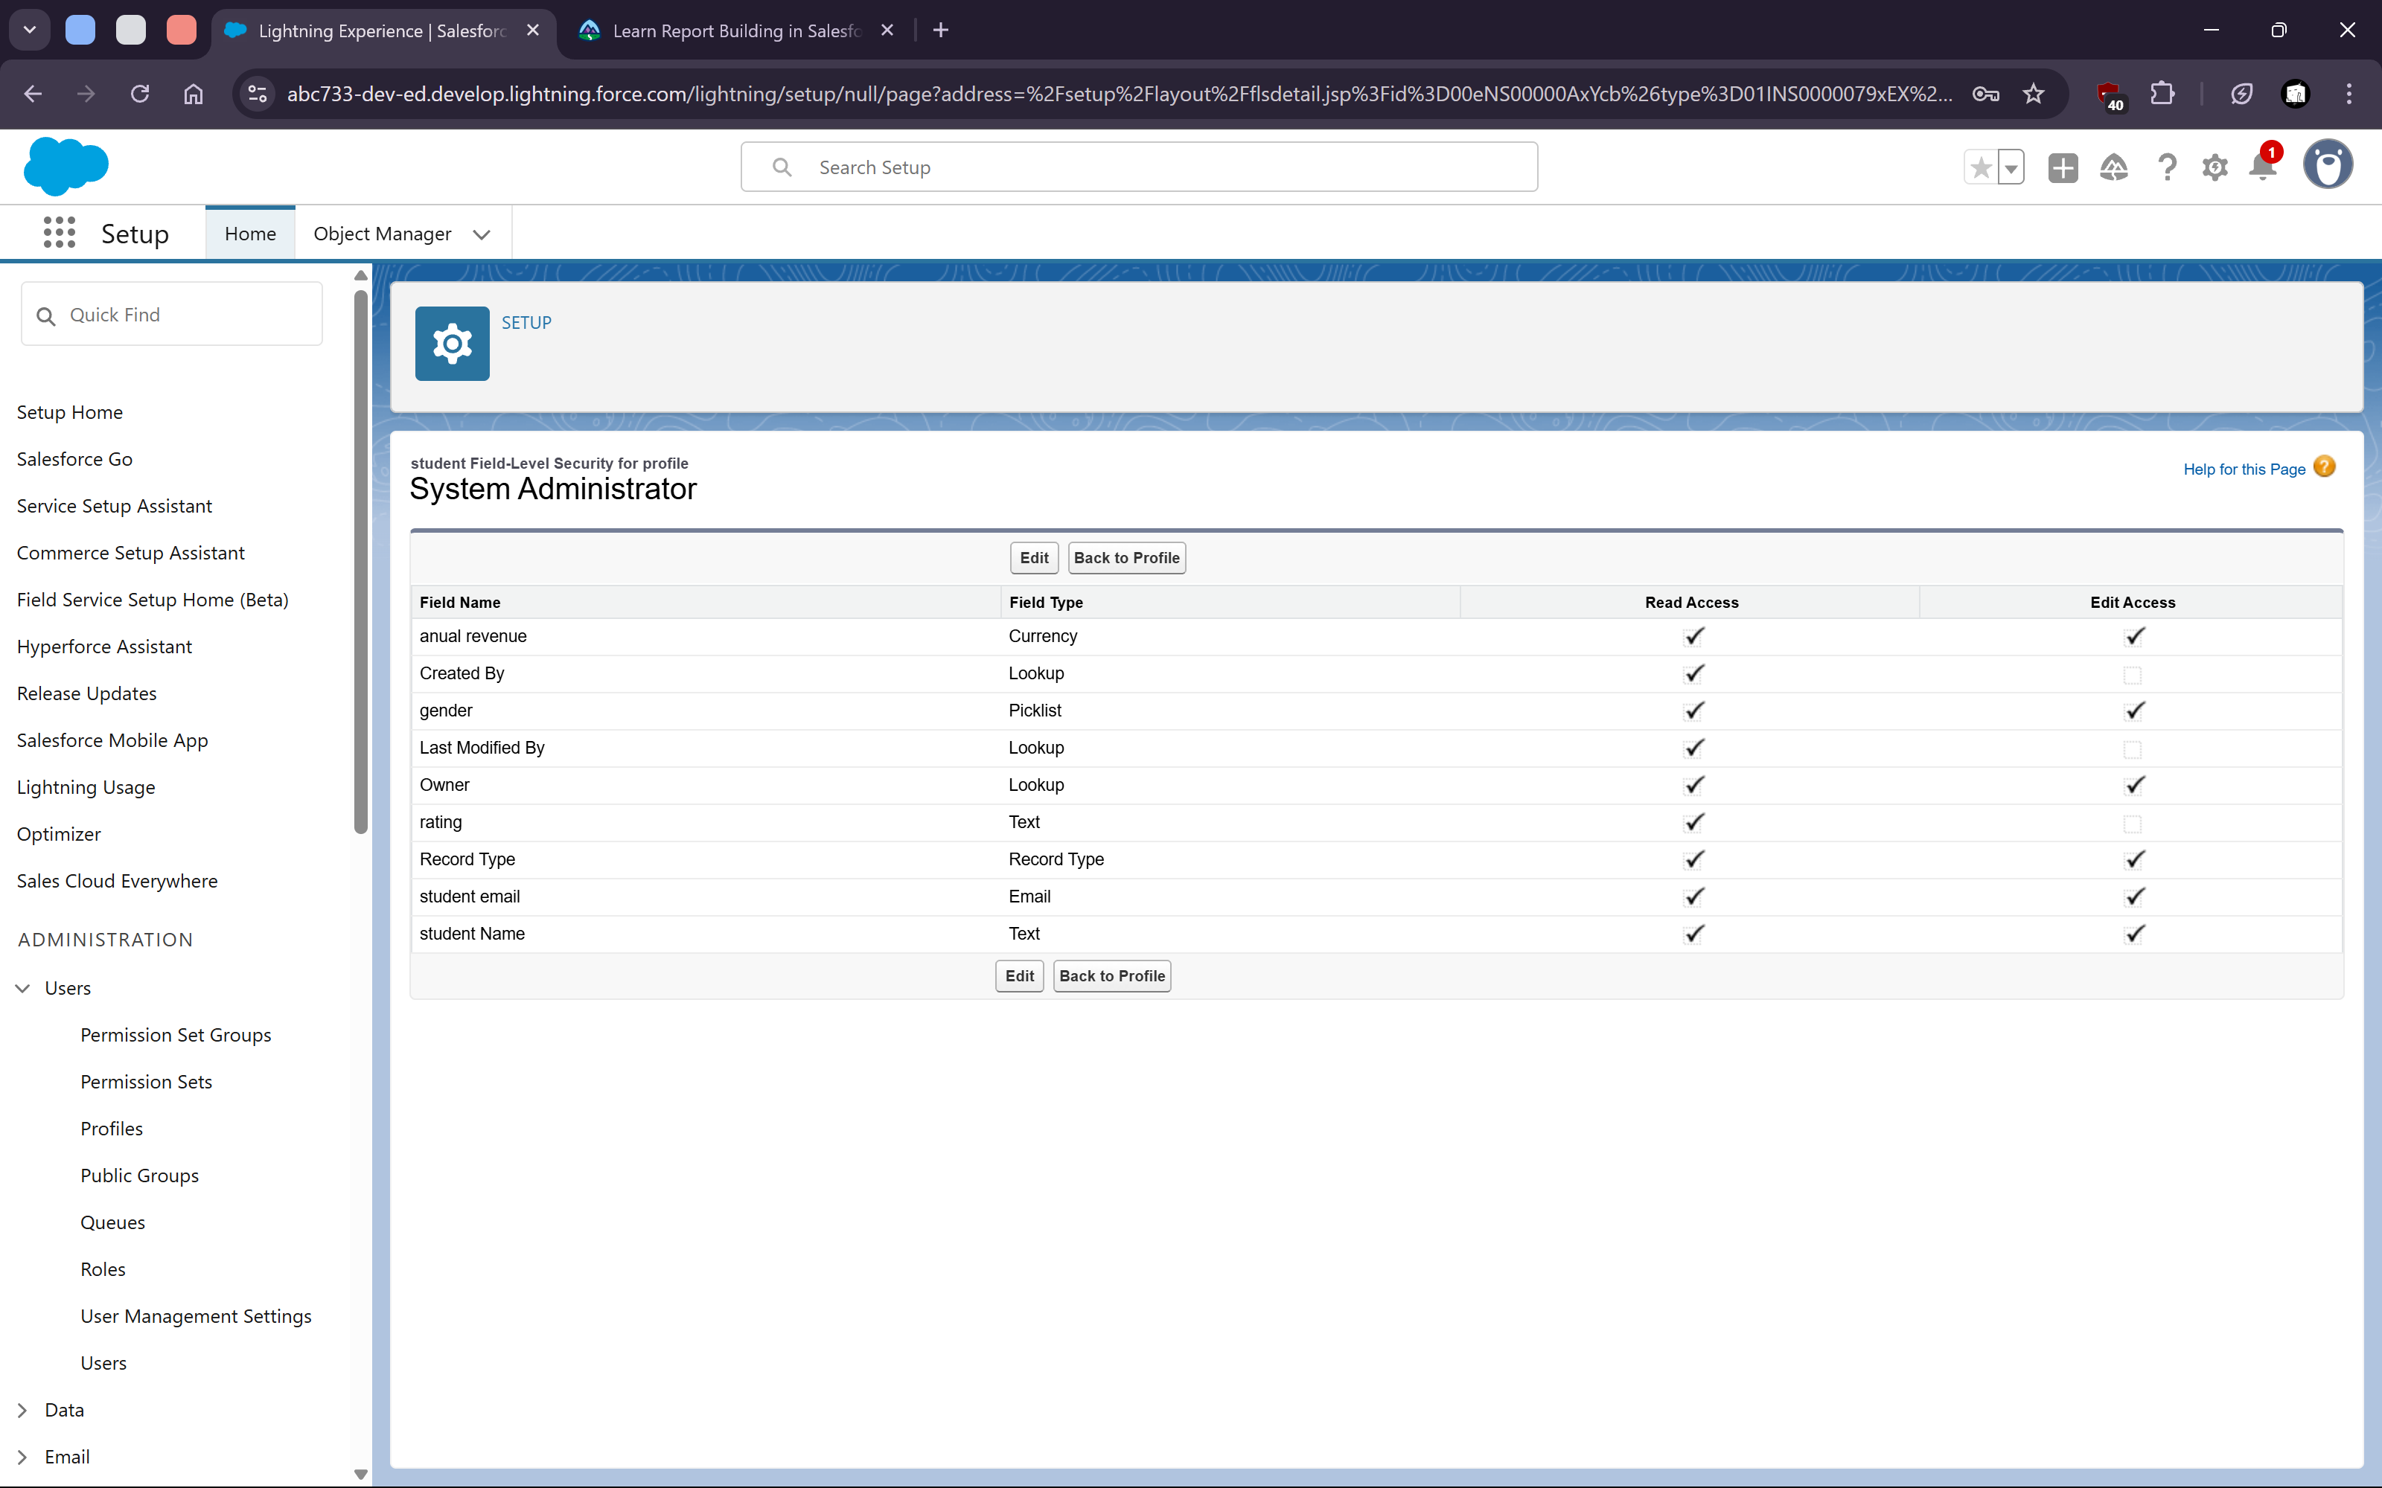
   3. We can also change standard and custom object permissions like create, read, write, delete etc.
   4. 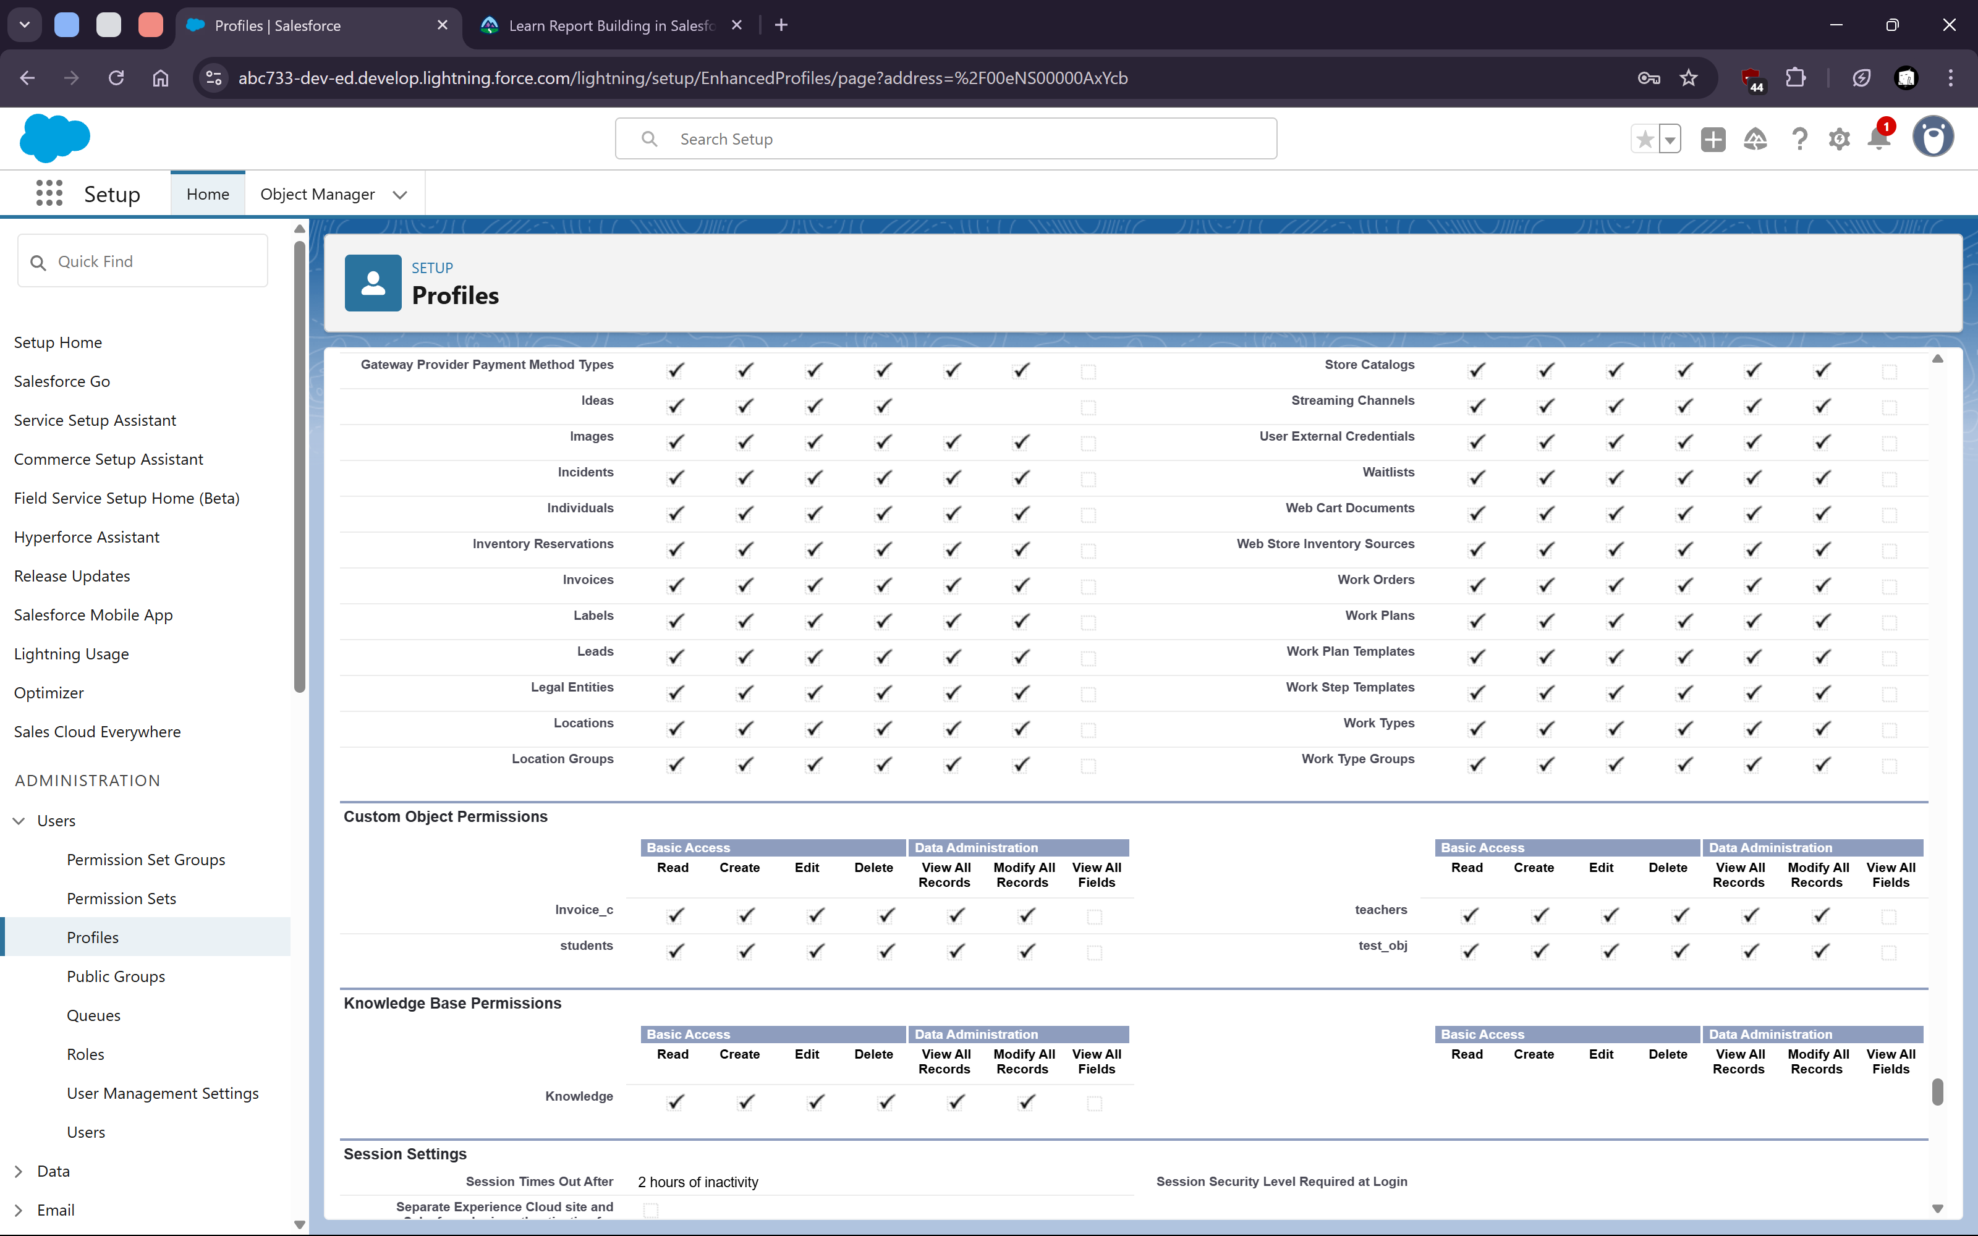
4. **Object manager and App Manager**
   1. Creating multiple custom objects
   2. 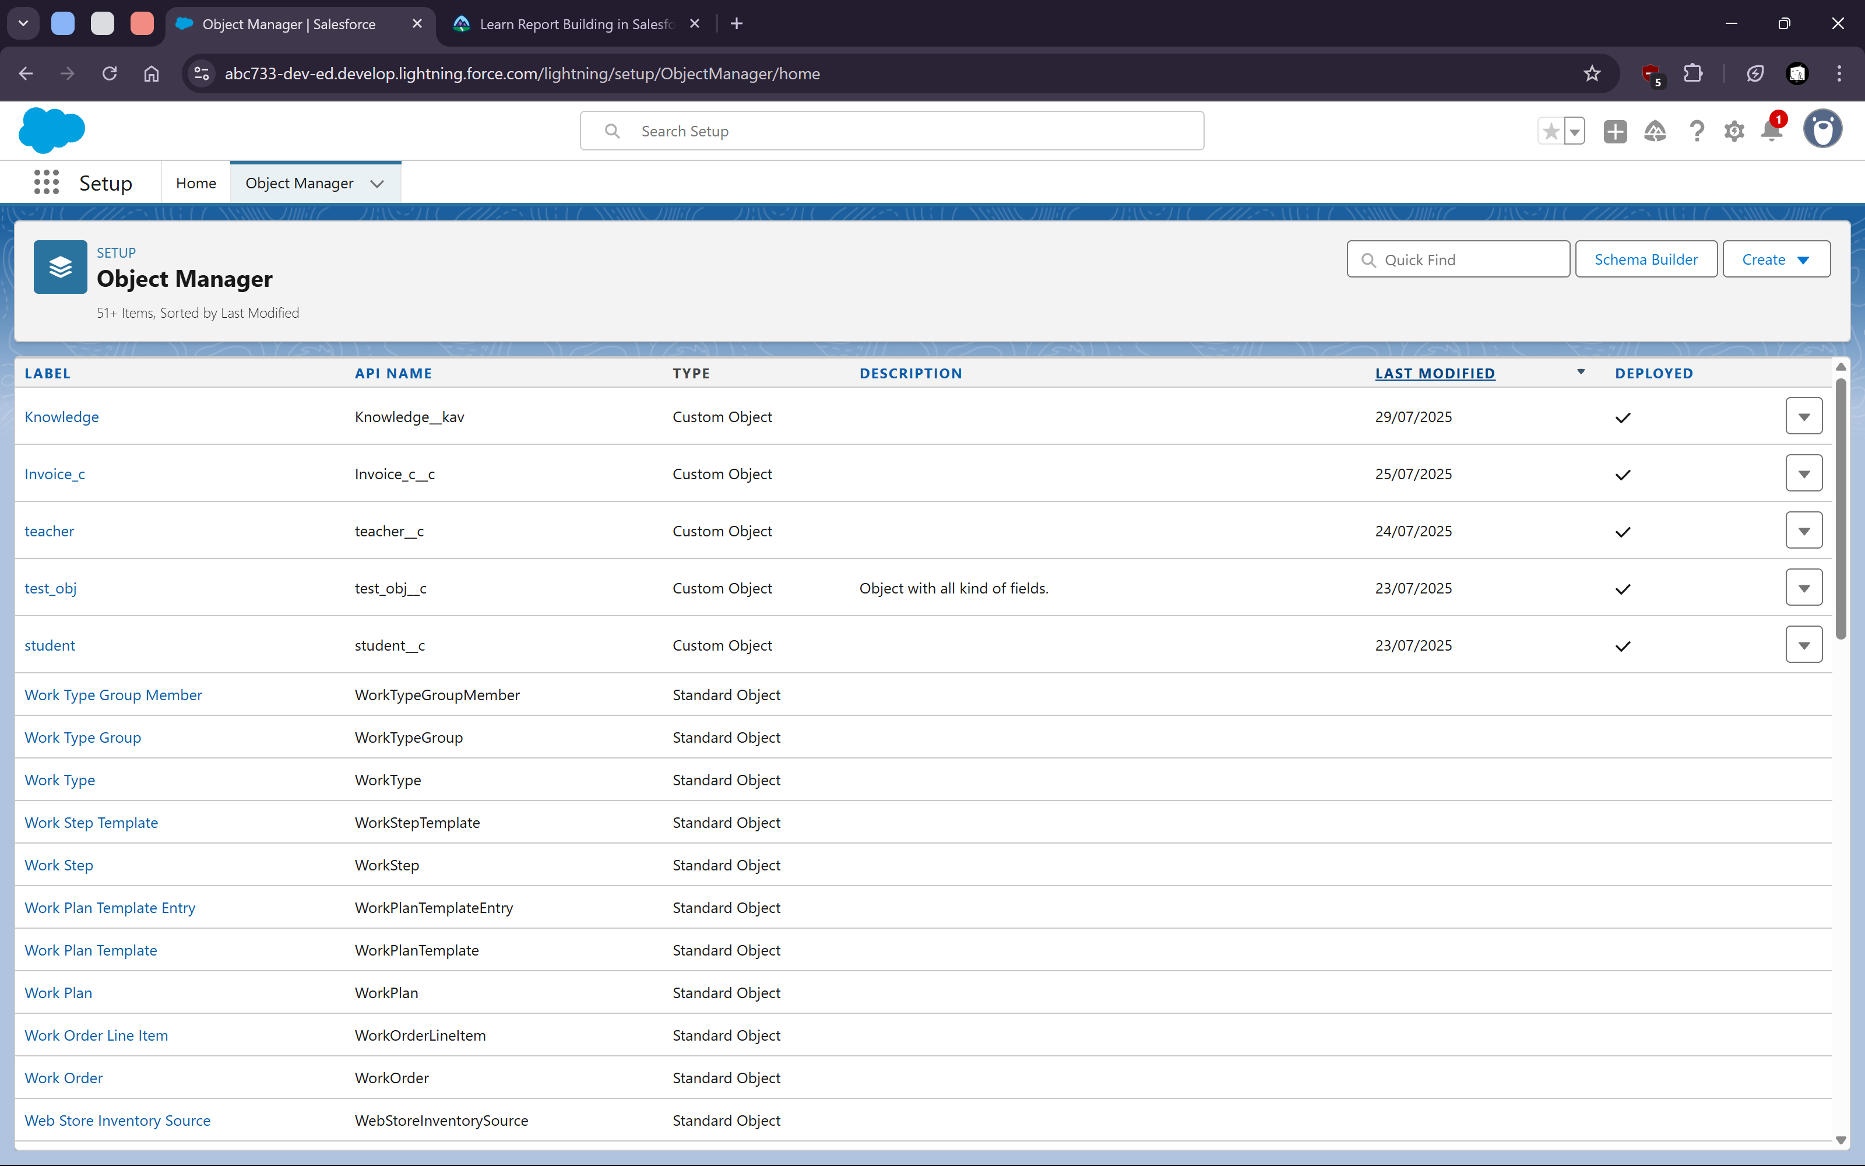
   4. Custom objects with all types of fields
   5. 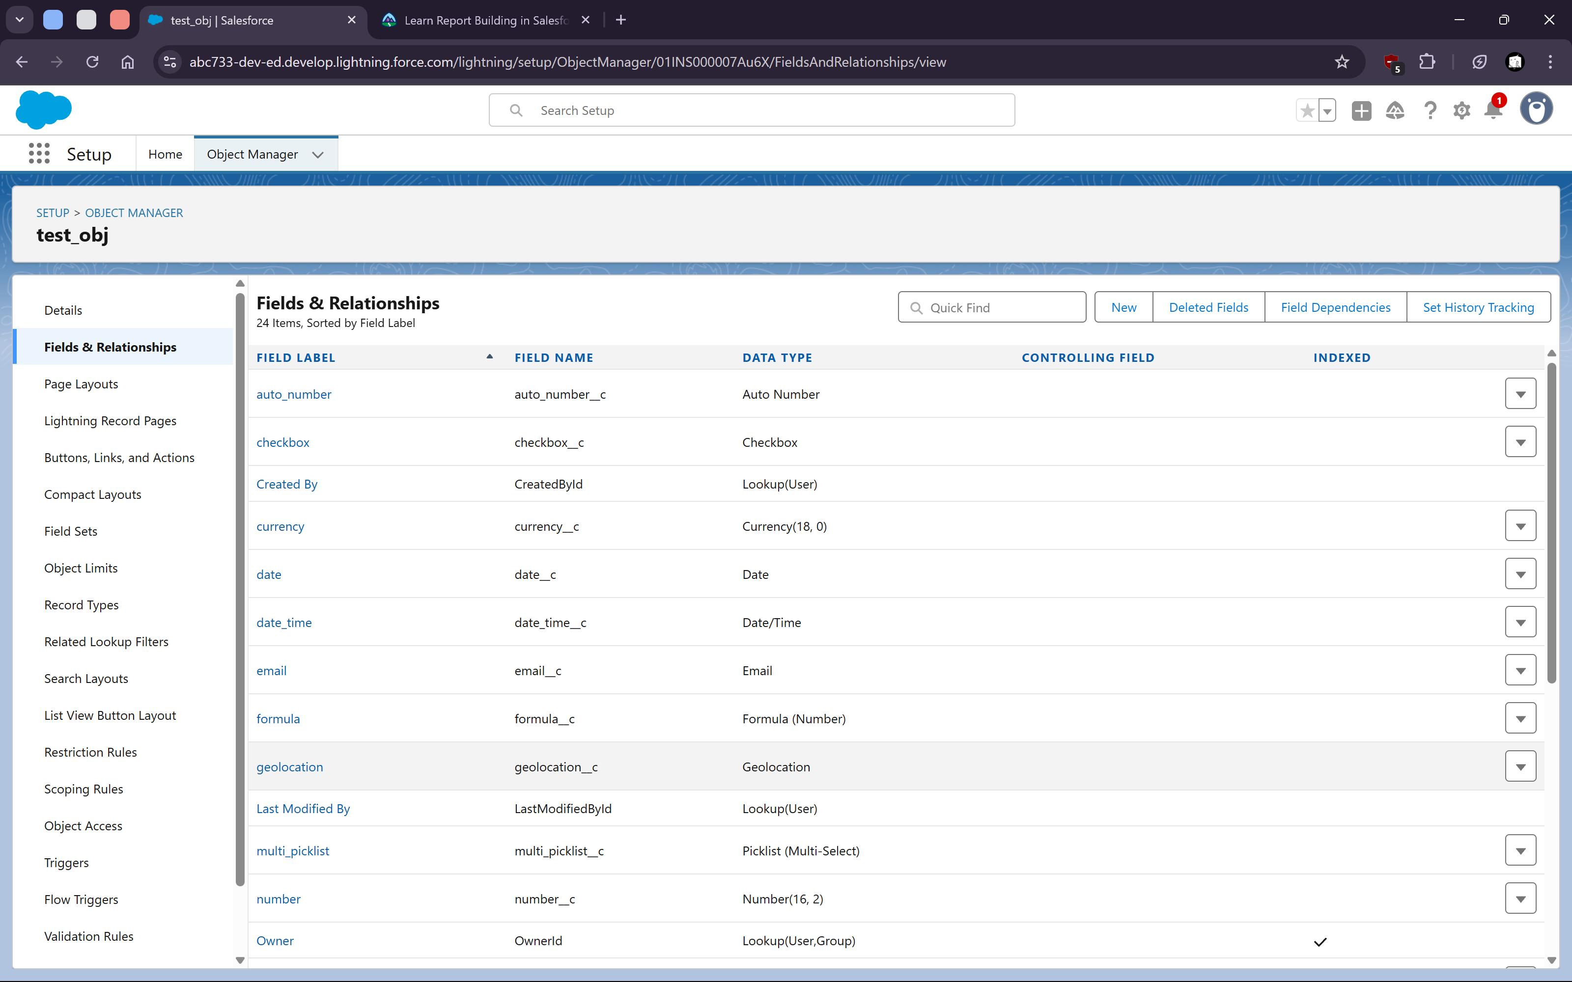
   7. 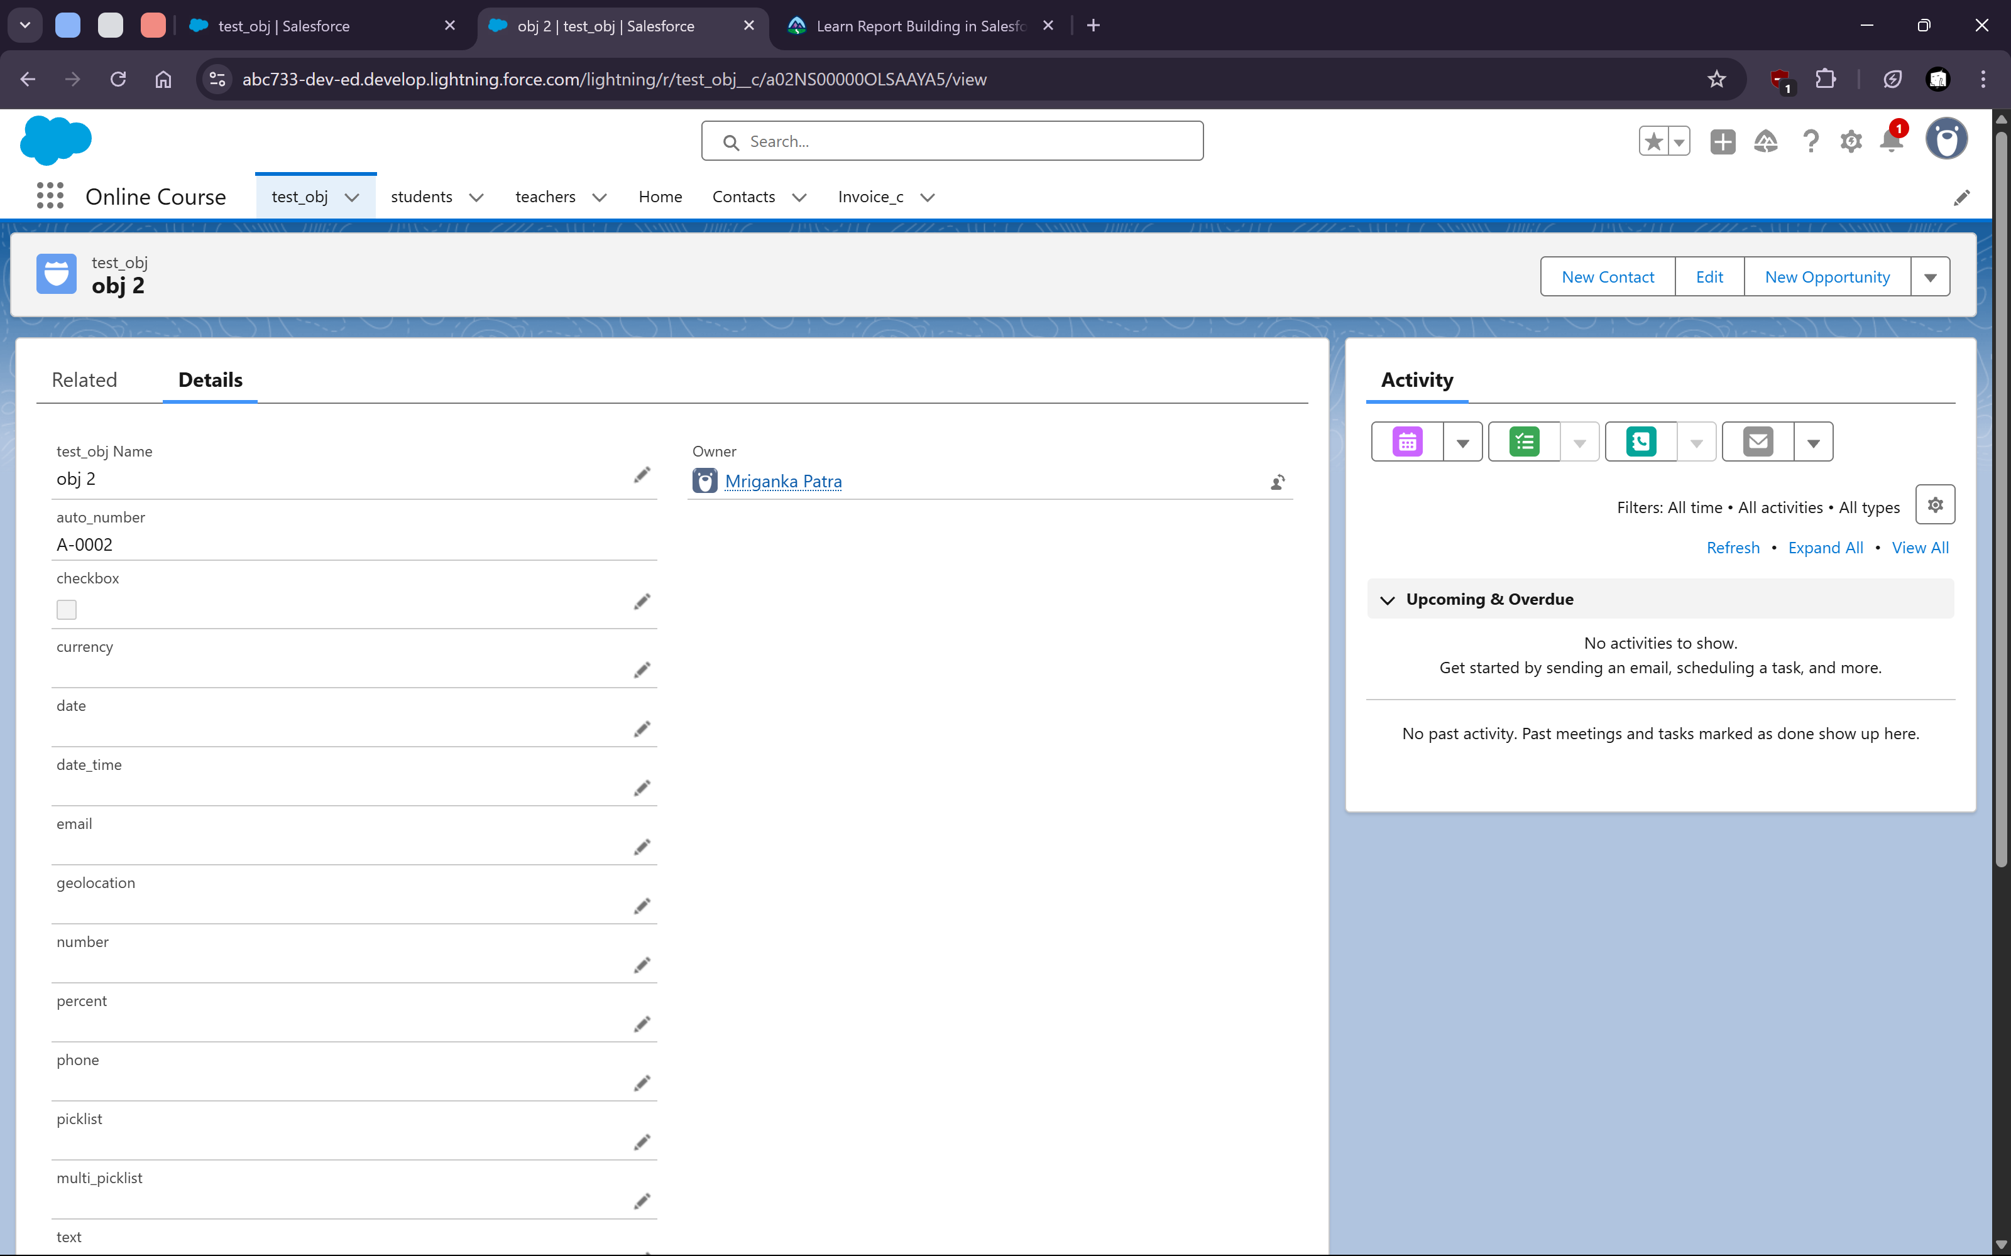
   9. Created custom Application with objects
   11. 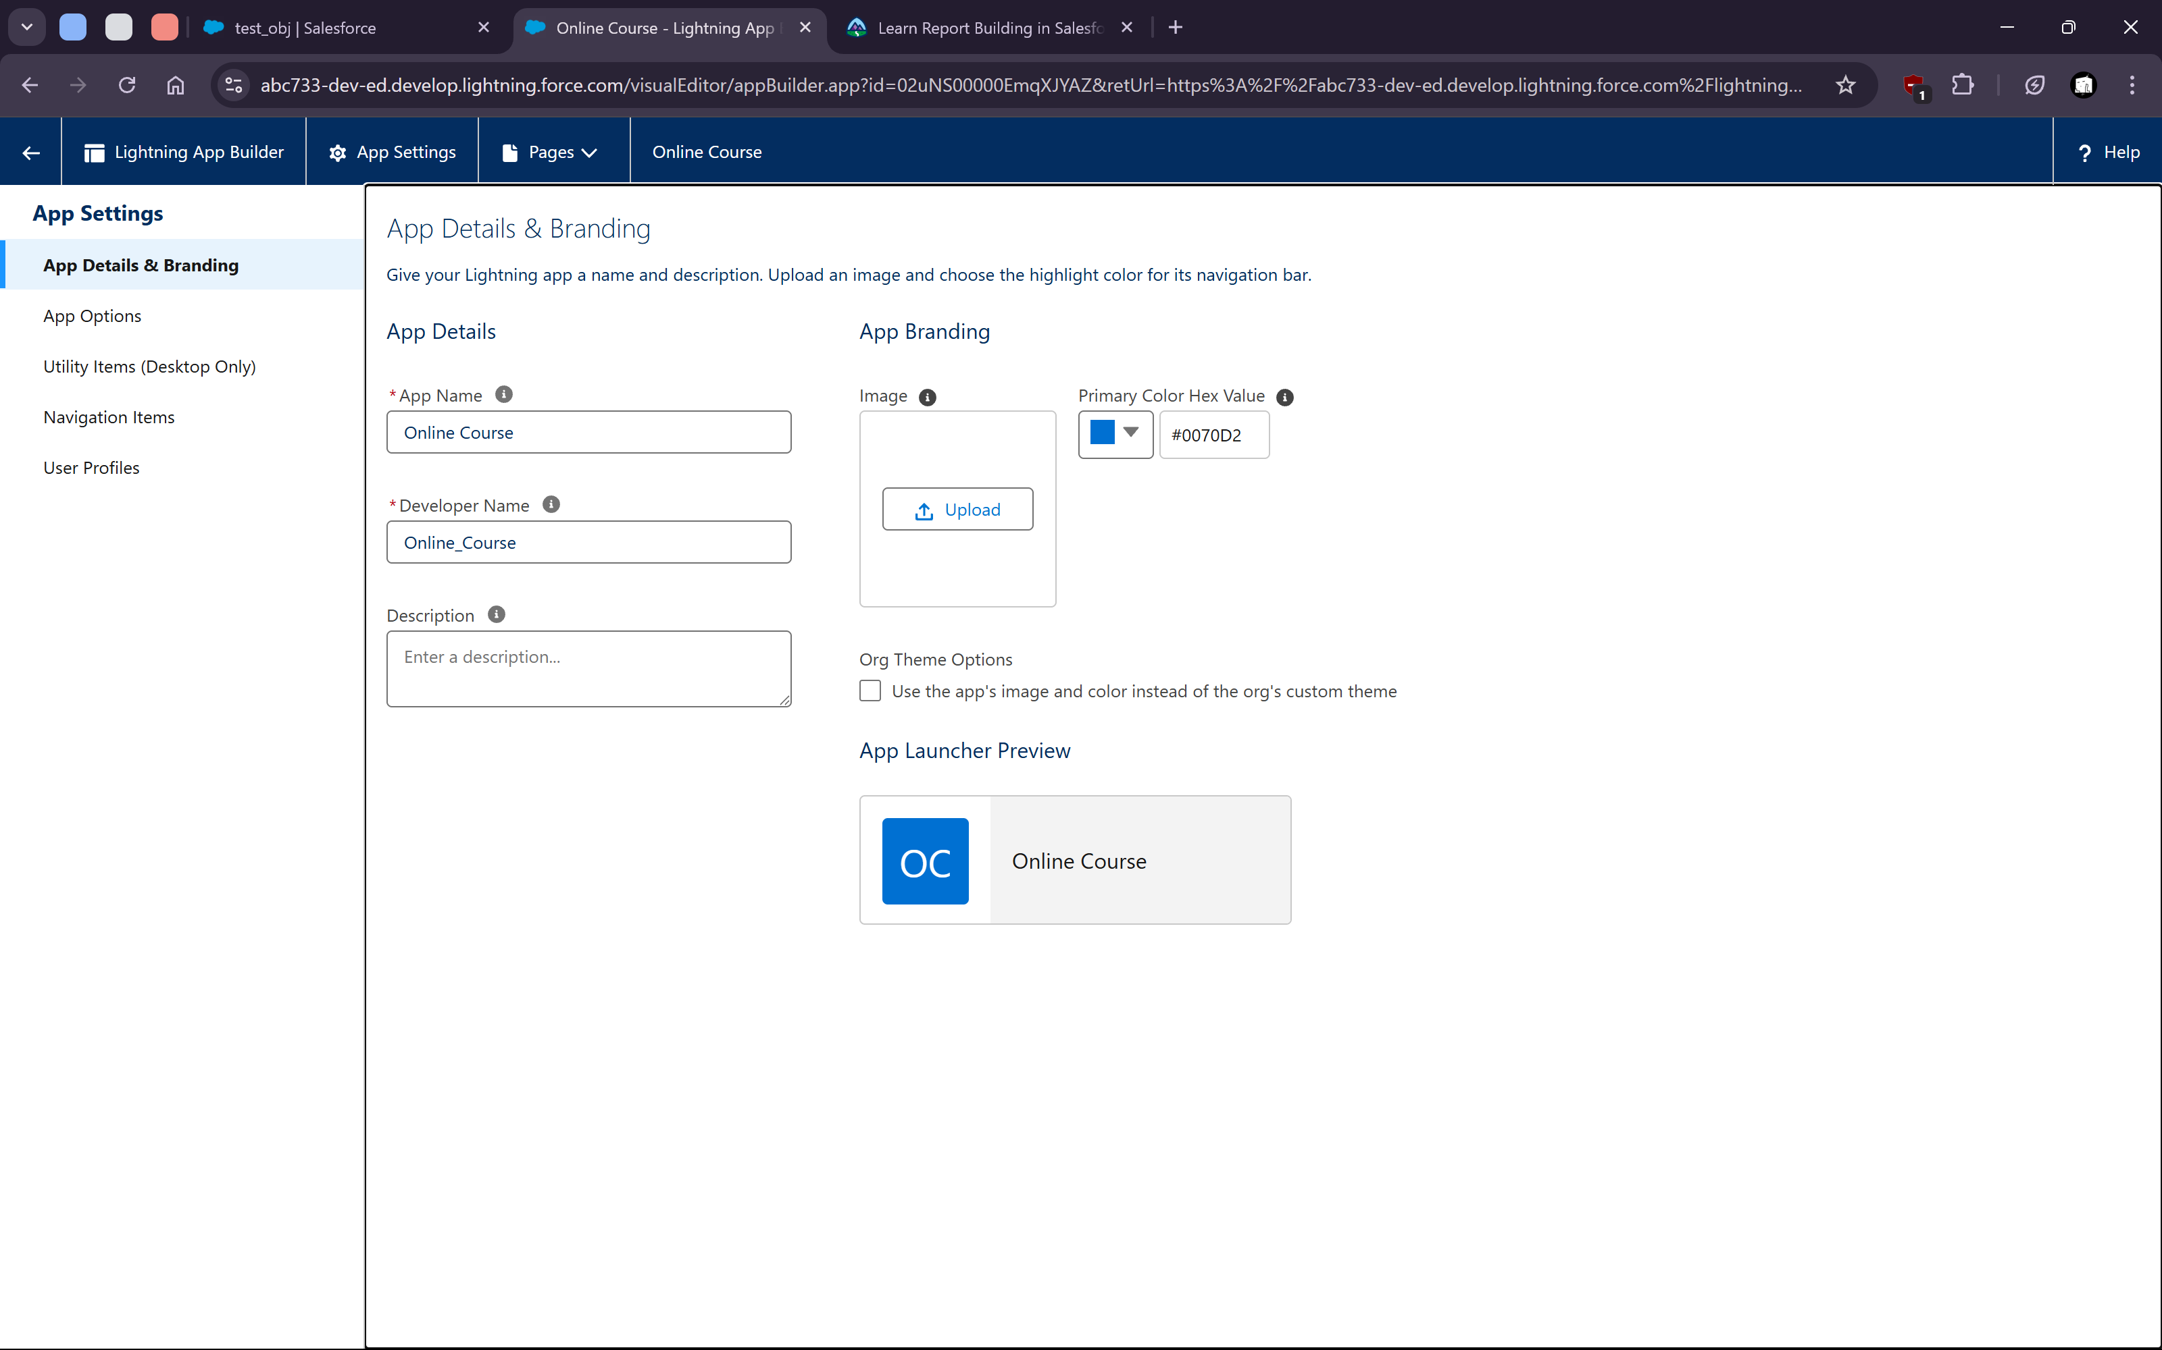
   13. 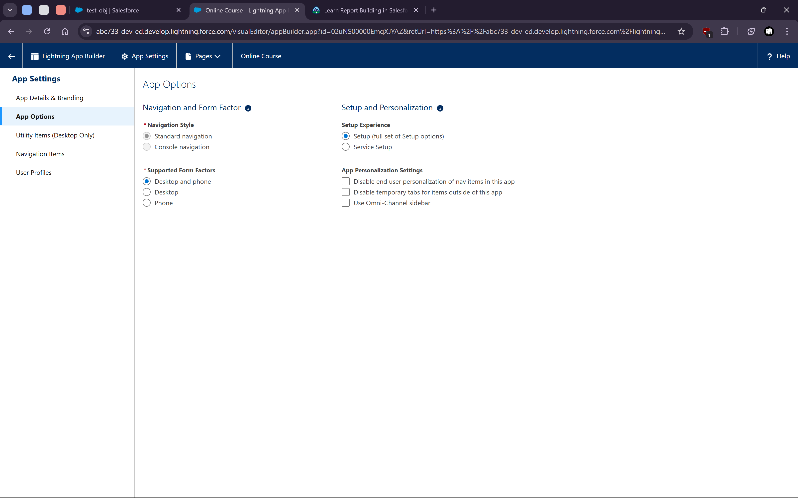
   15. 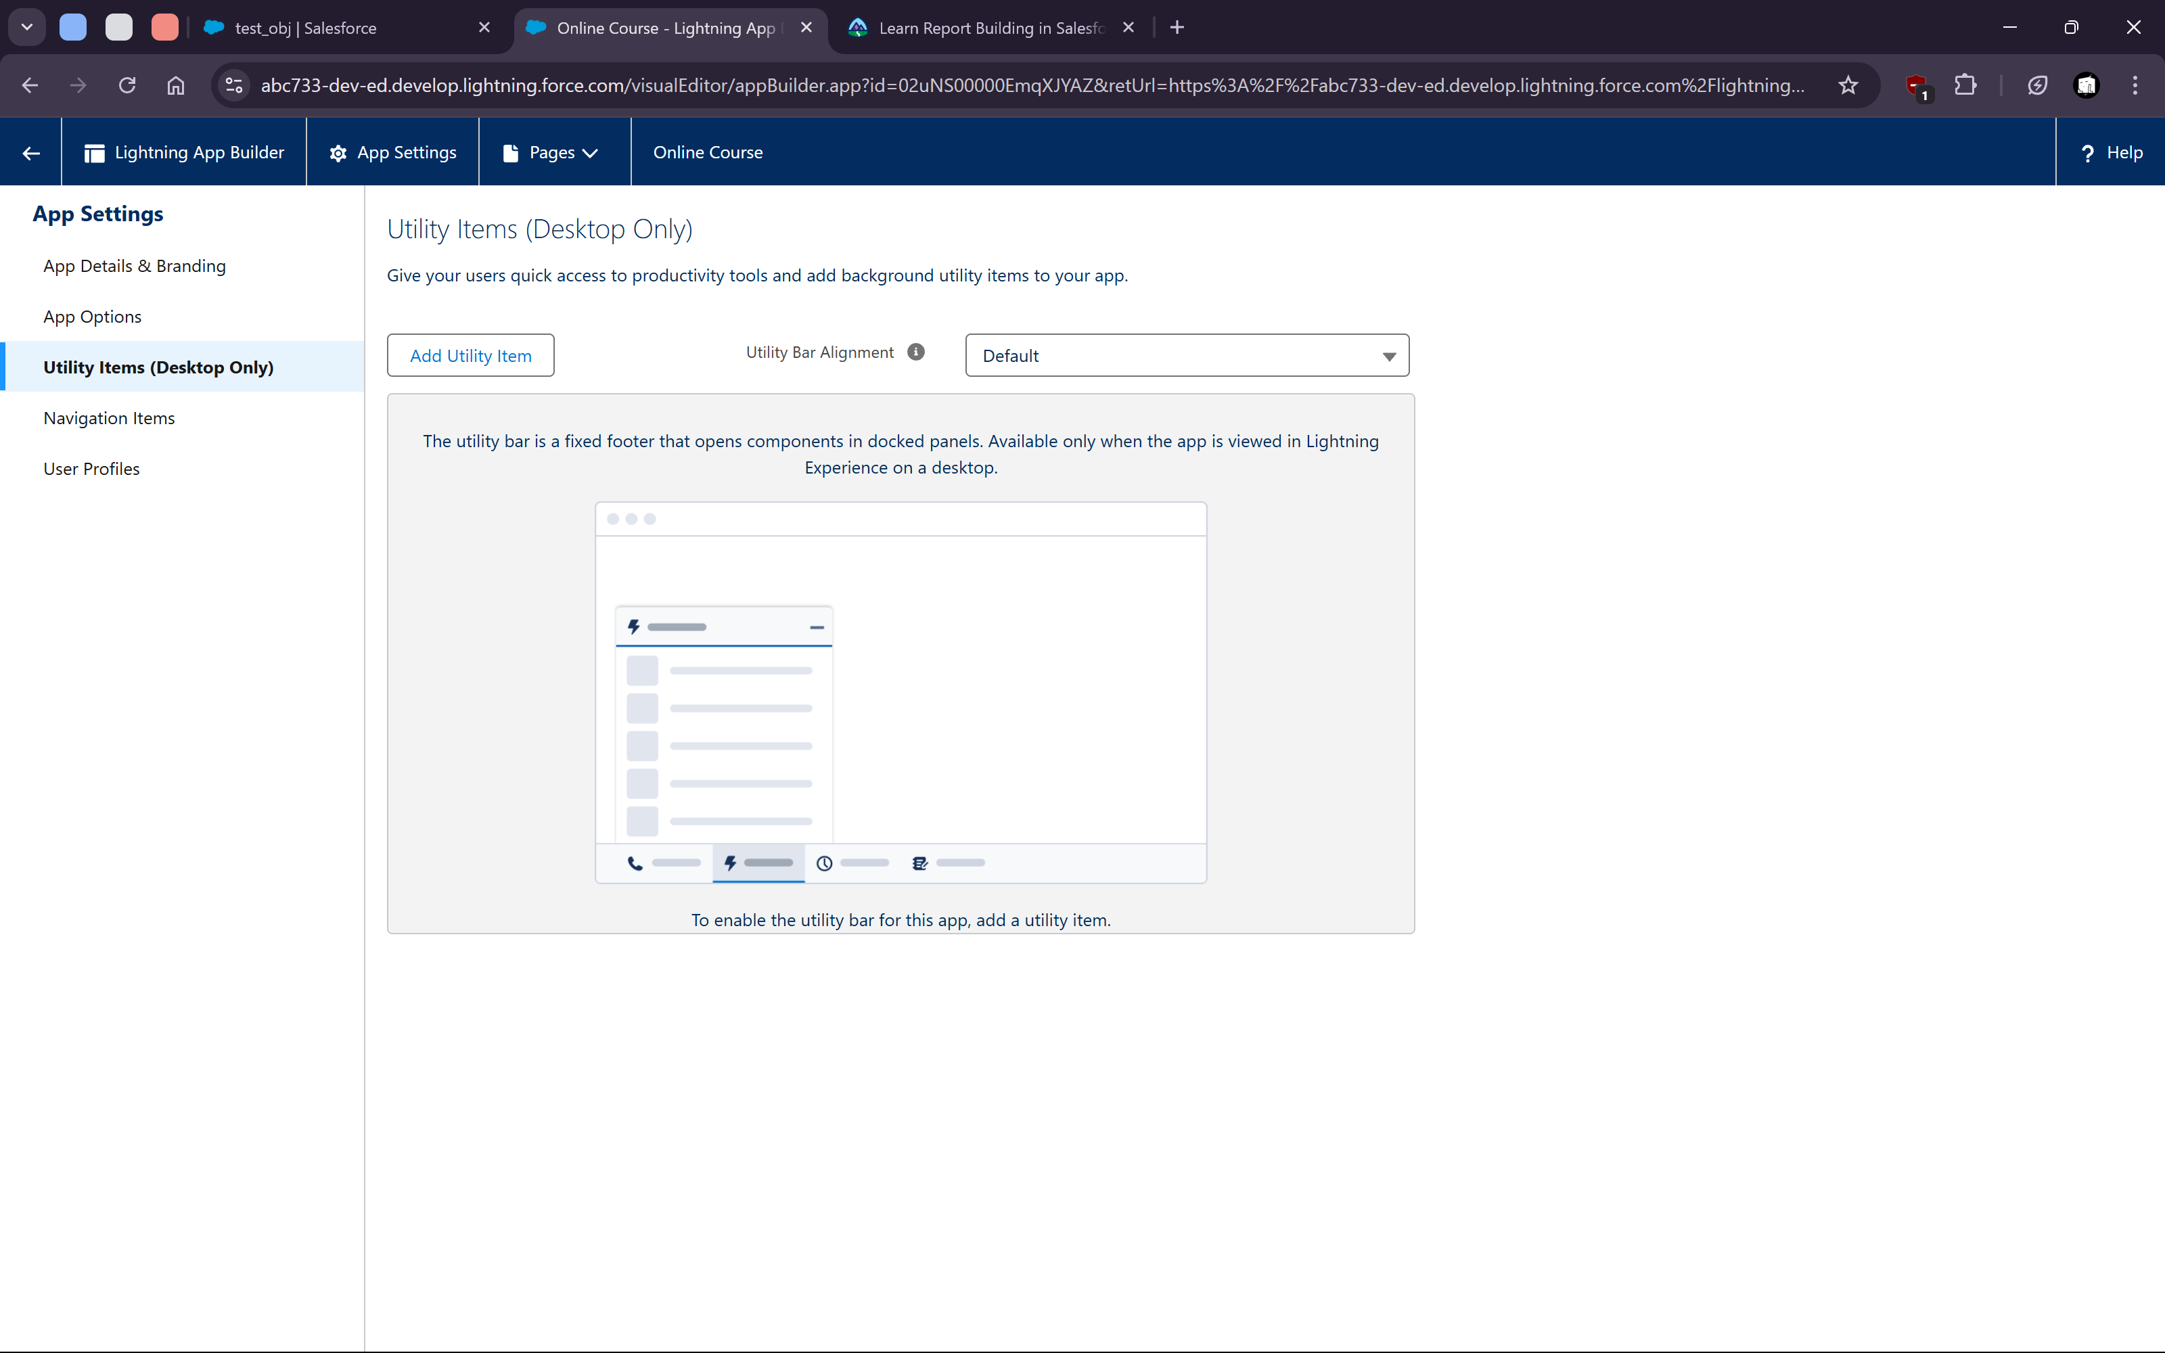
   17. 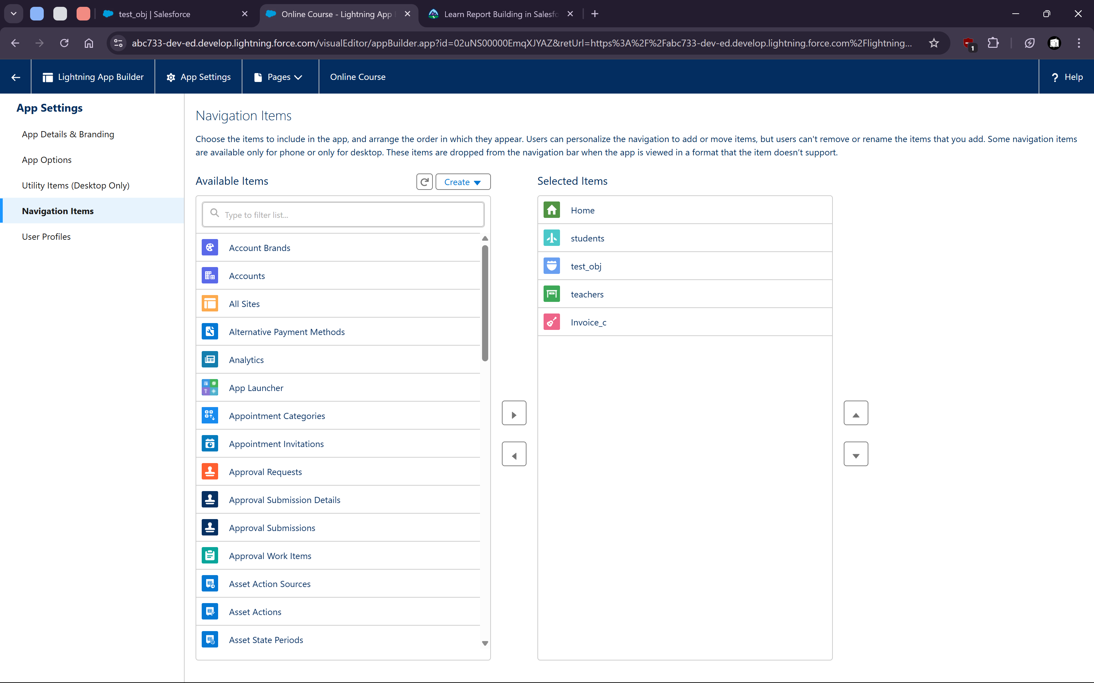

   20. 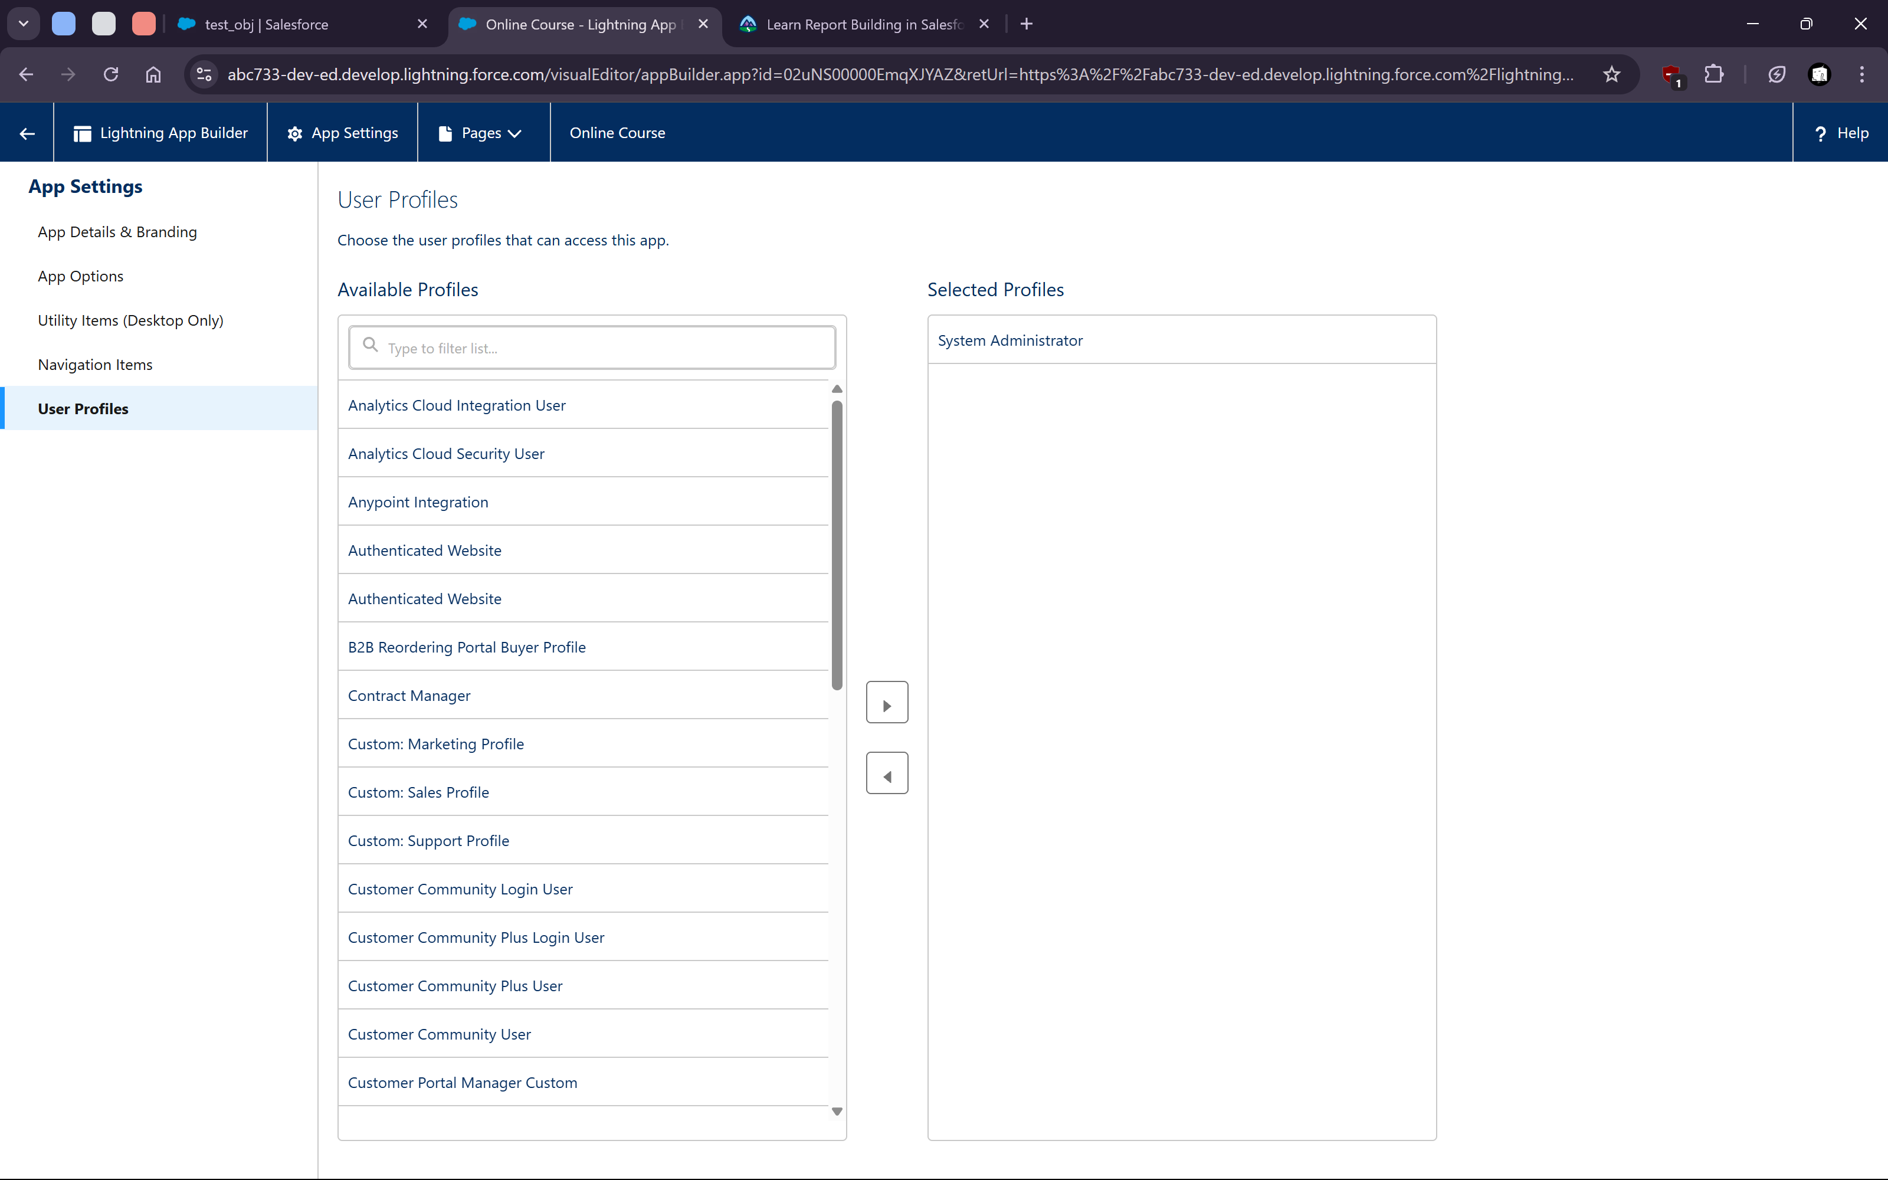
5. **Web To Lead**
   1. 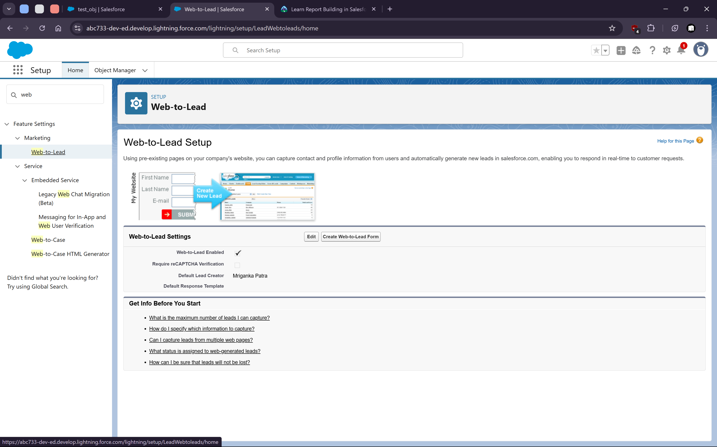
6. **Web to Case** 
   1. 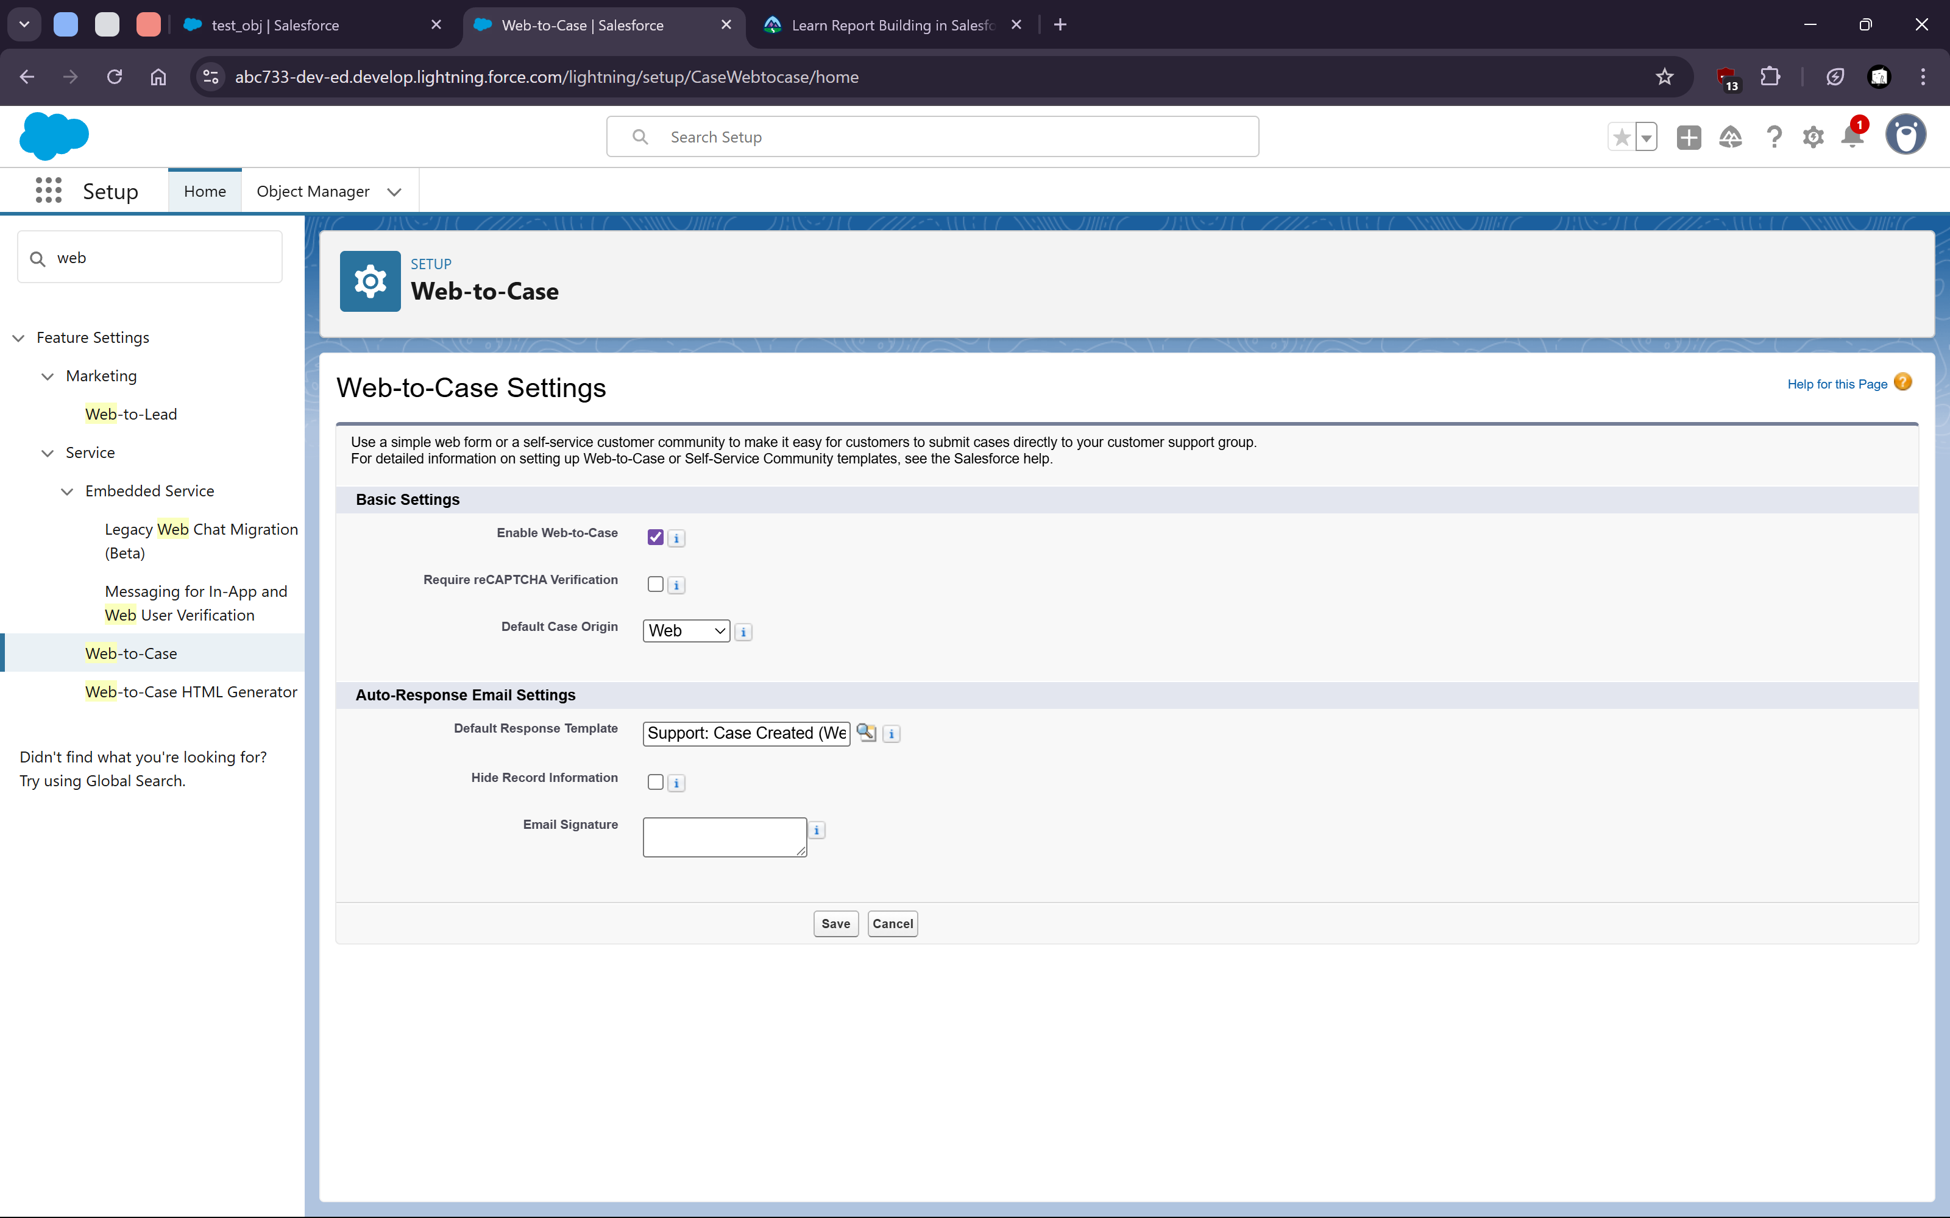
7. Page Layout and Record types
   1. 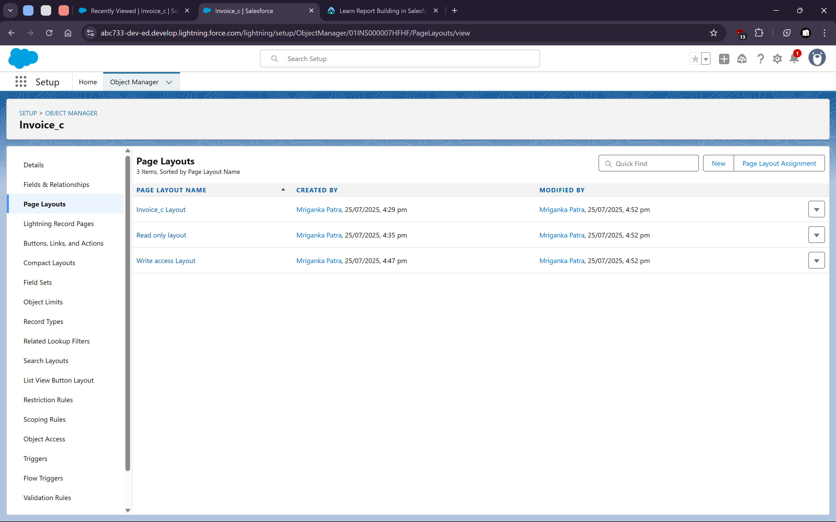

   4. 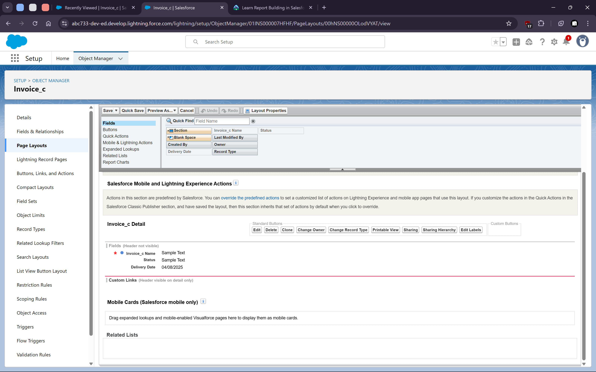

   7. Record types
   8. 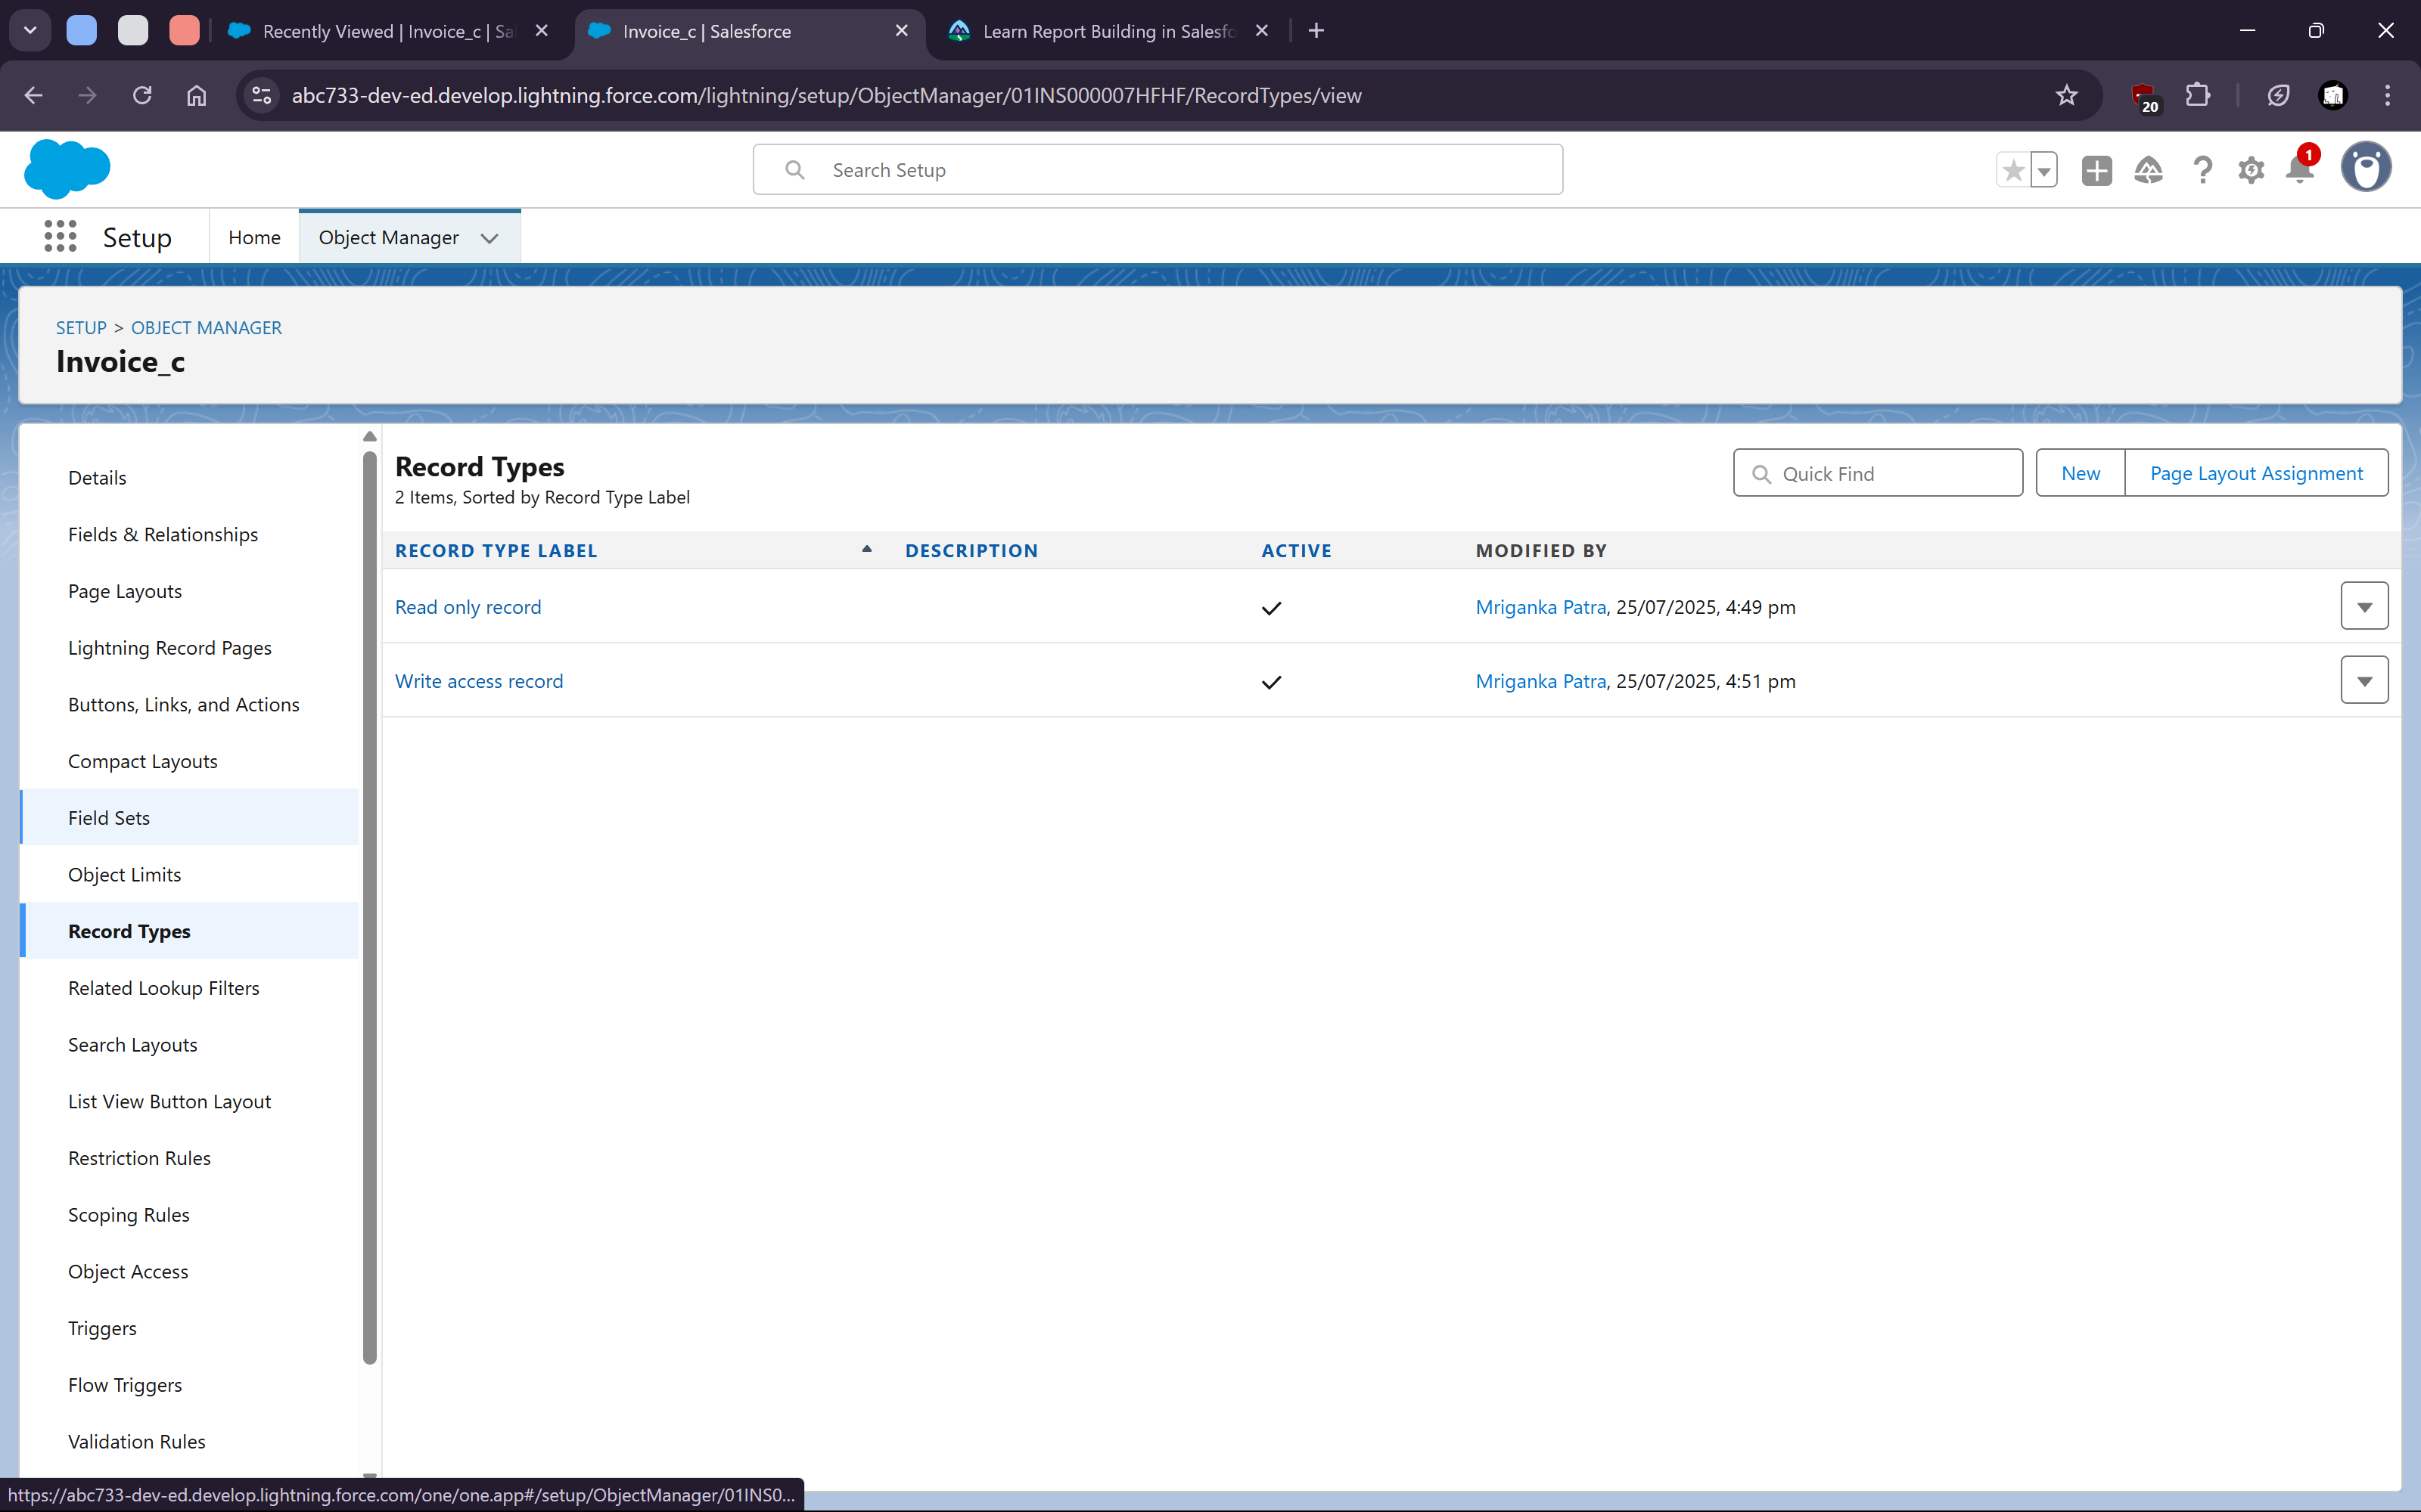

   11. 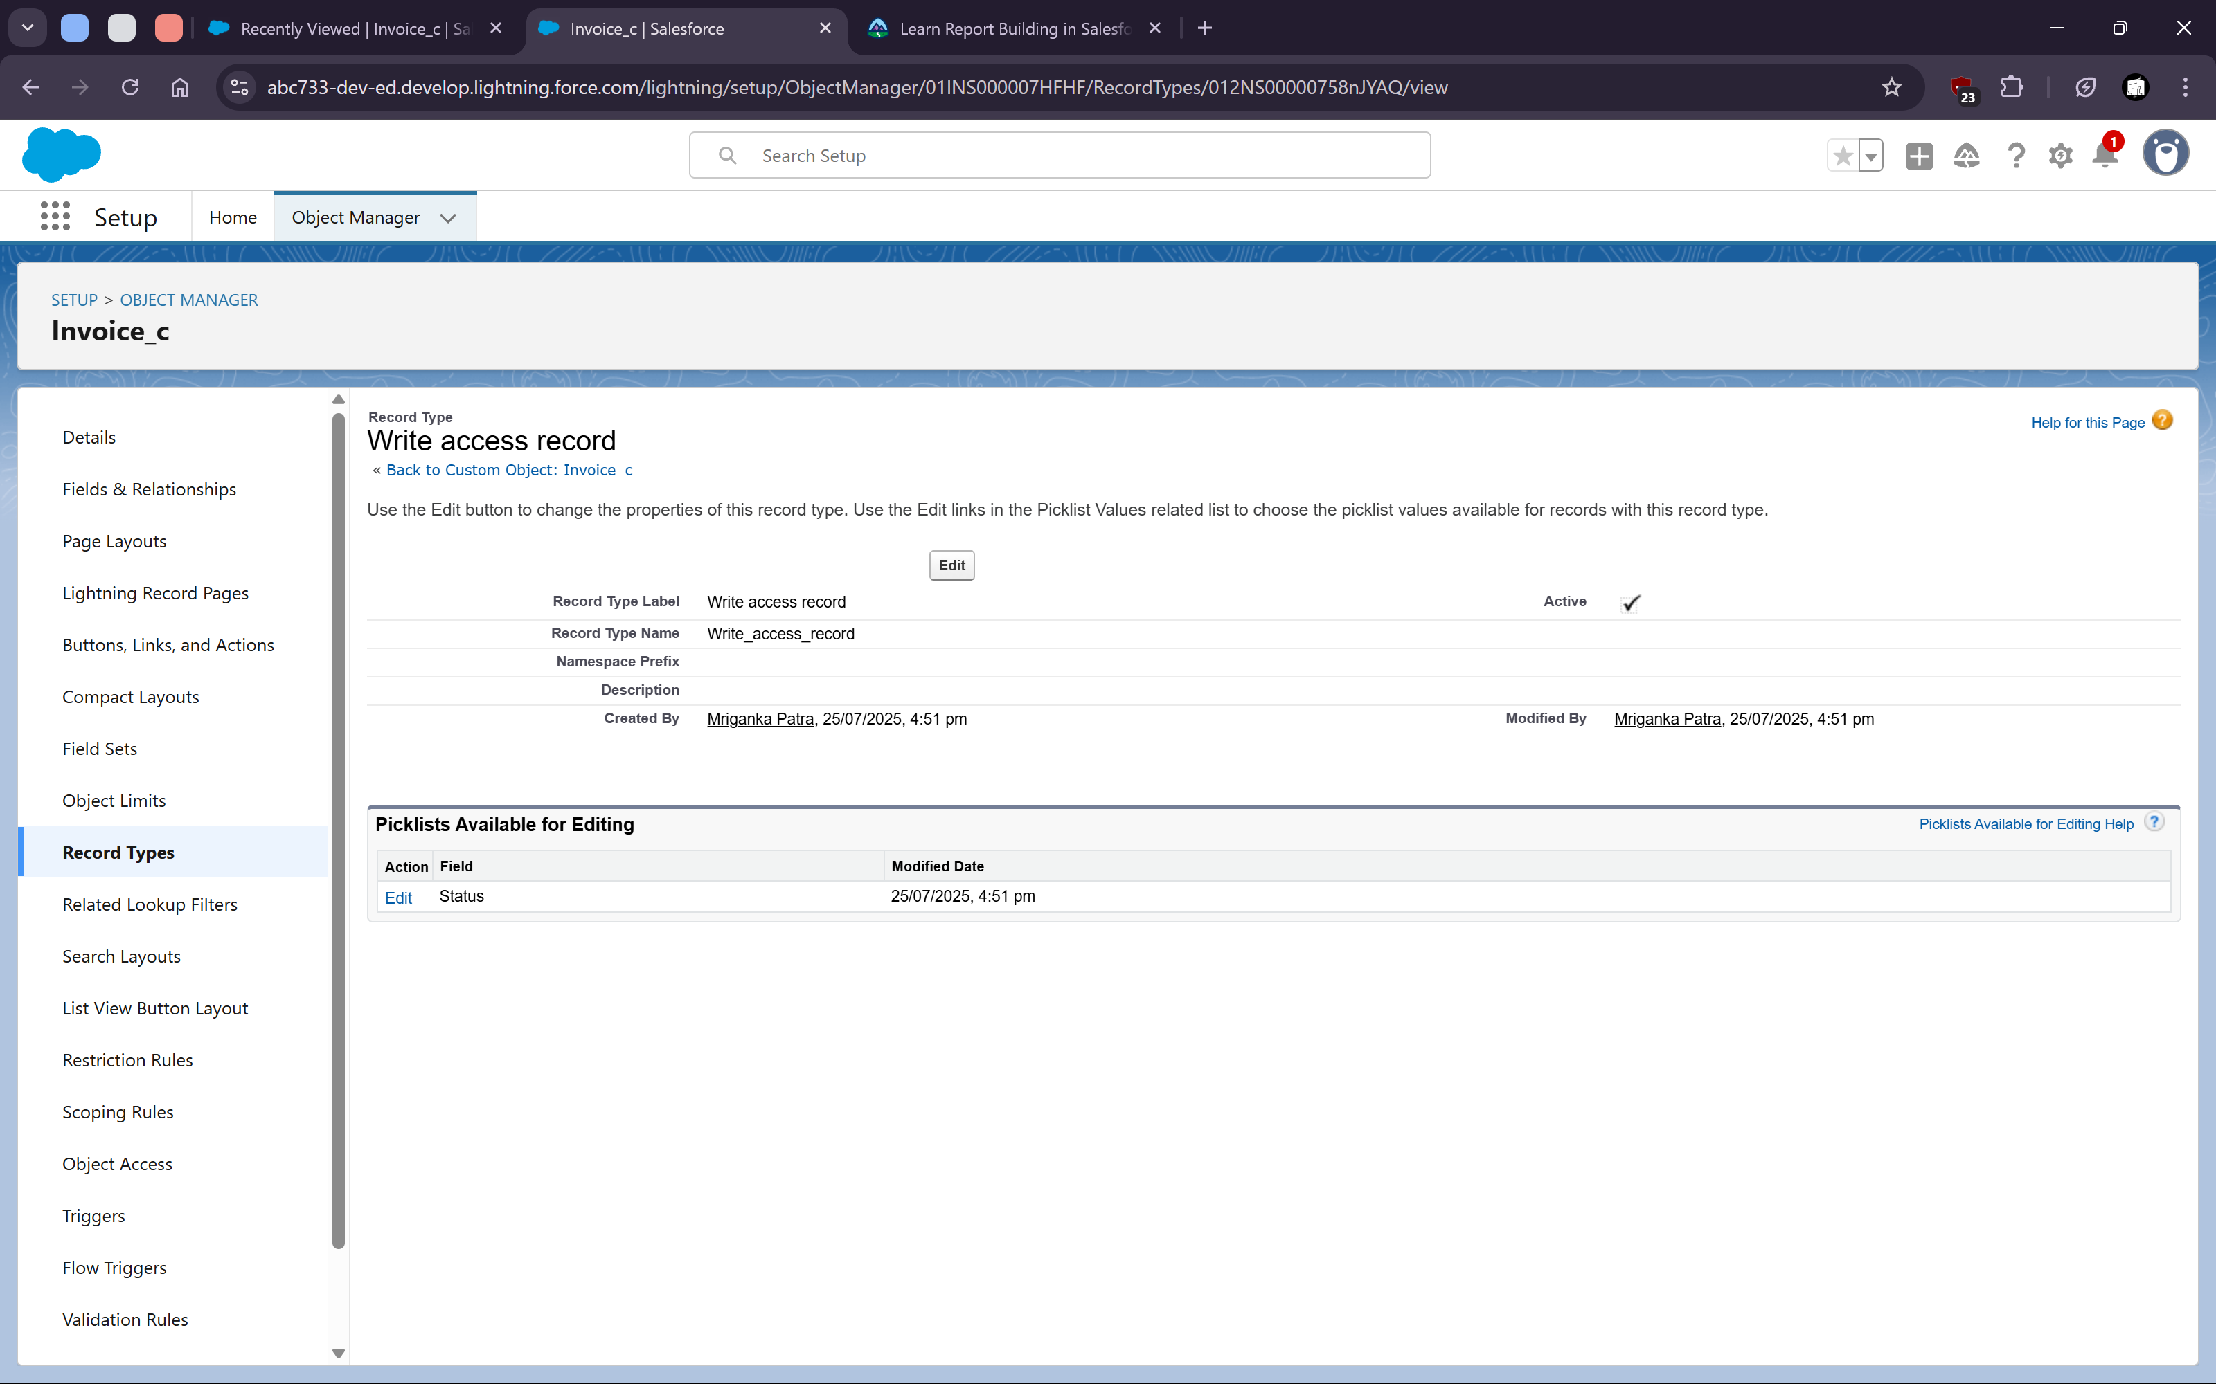
8. **Data Import wizard**
   1. Importing data using csv files
   2. 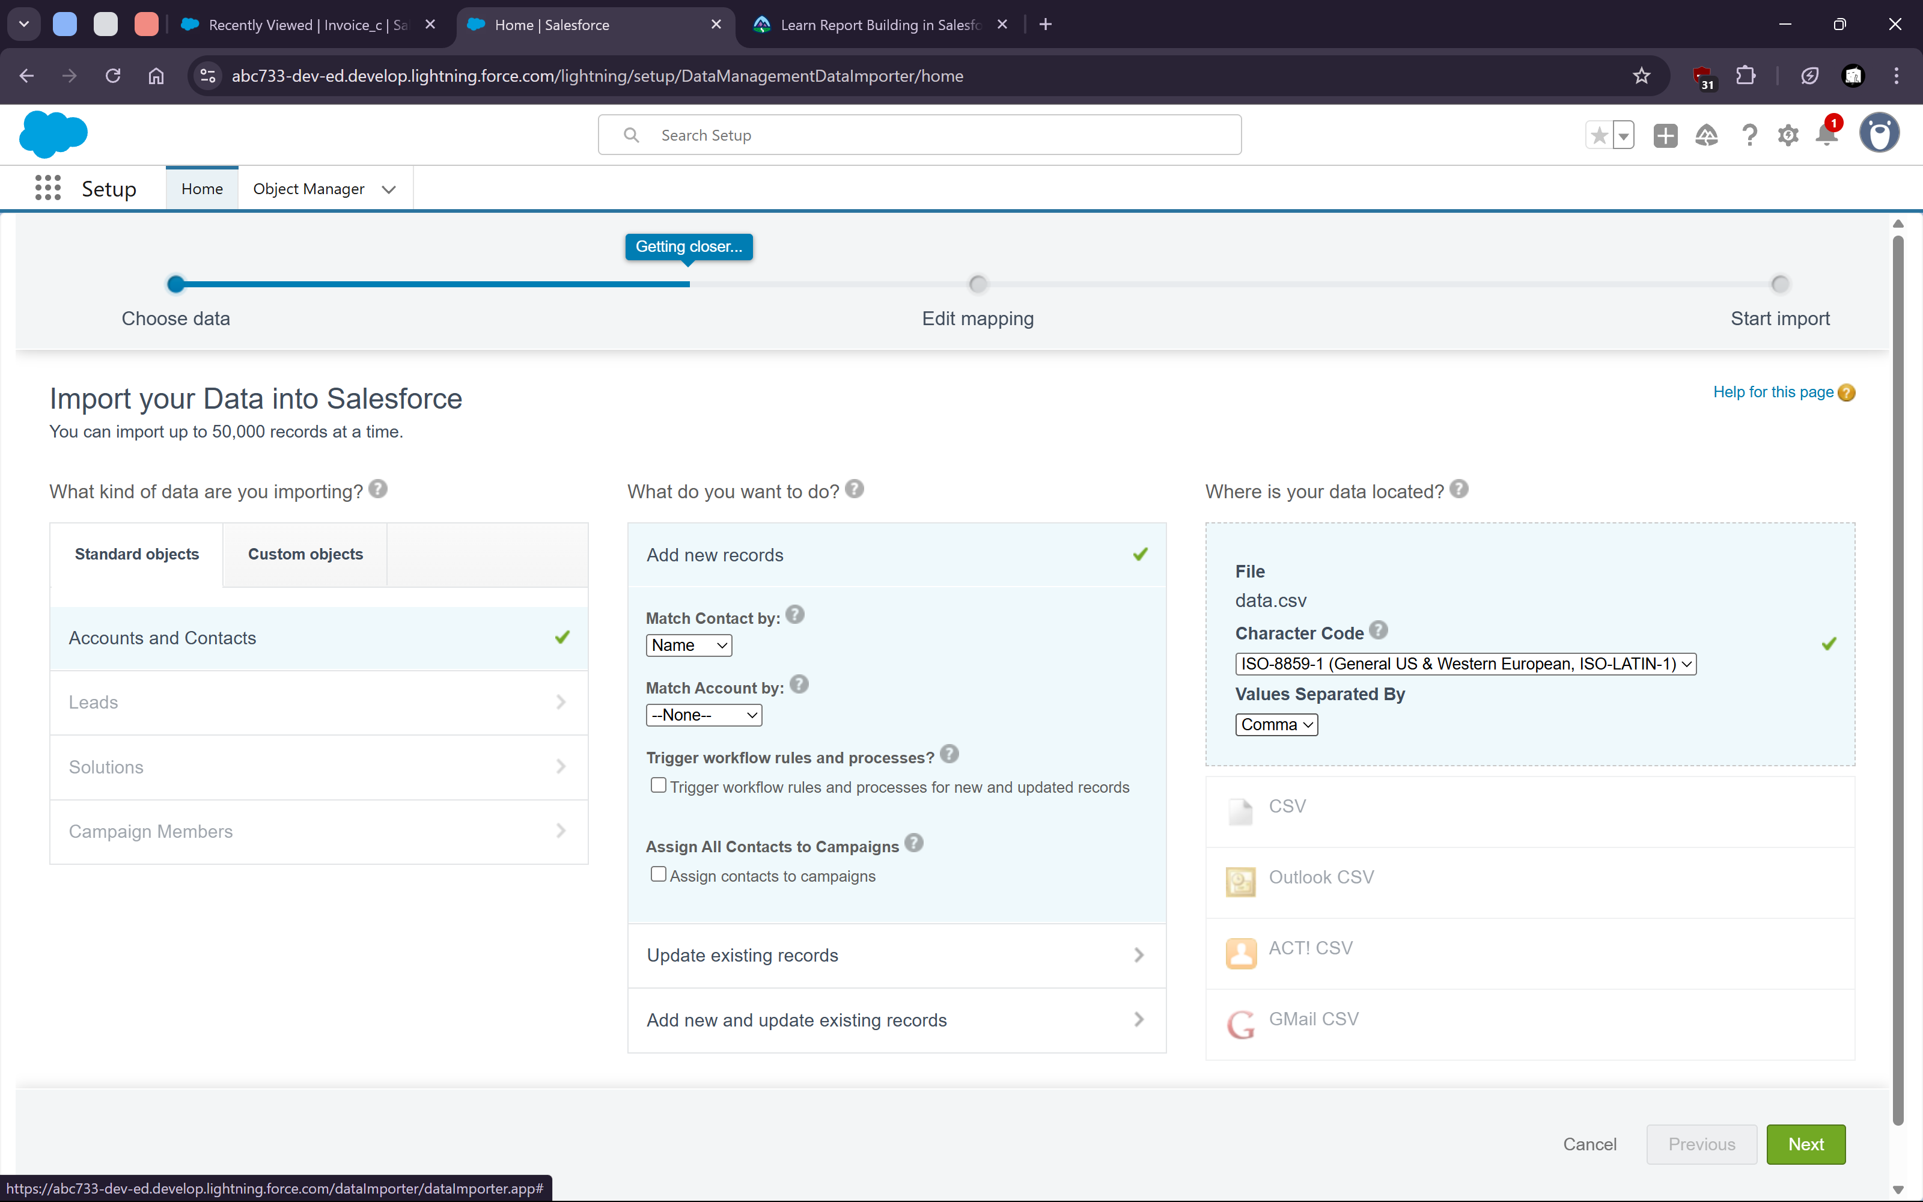


   6. Map the fields
   7. 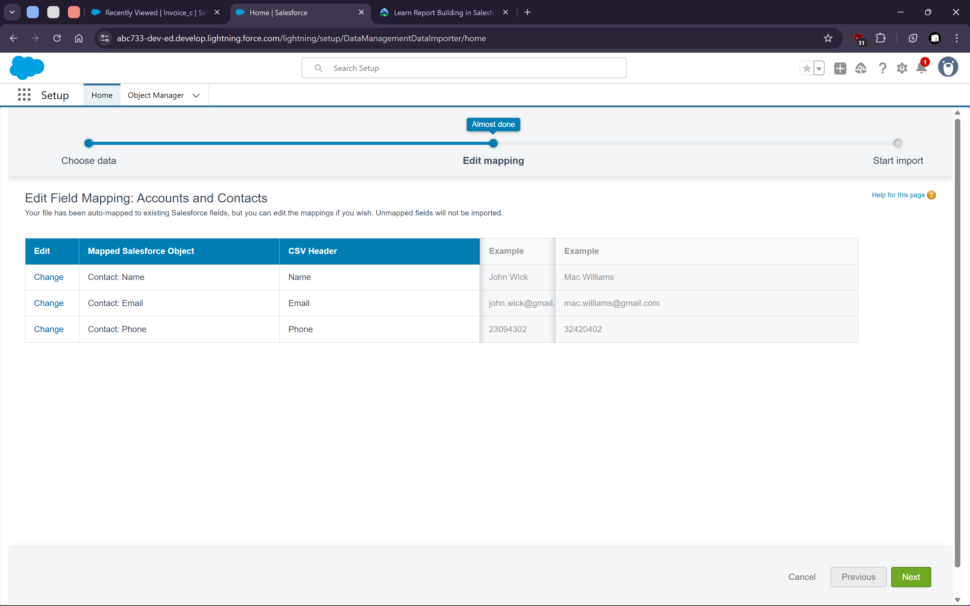
   9. Import the data
   11. 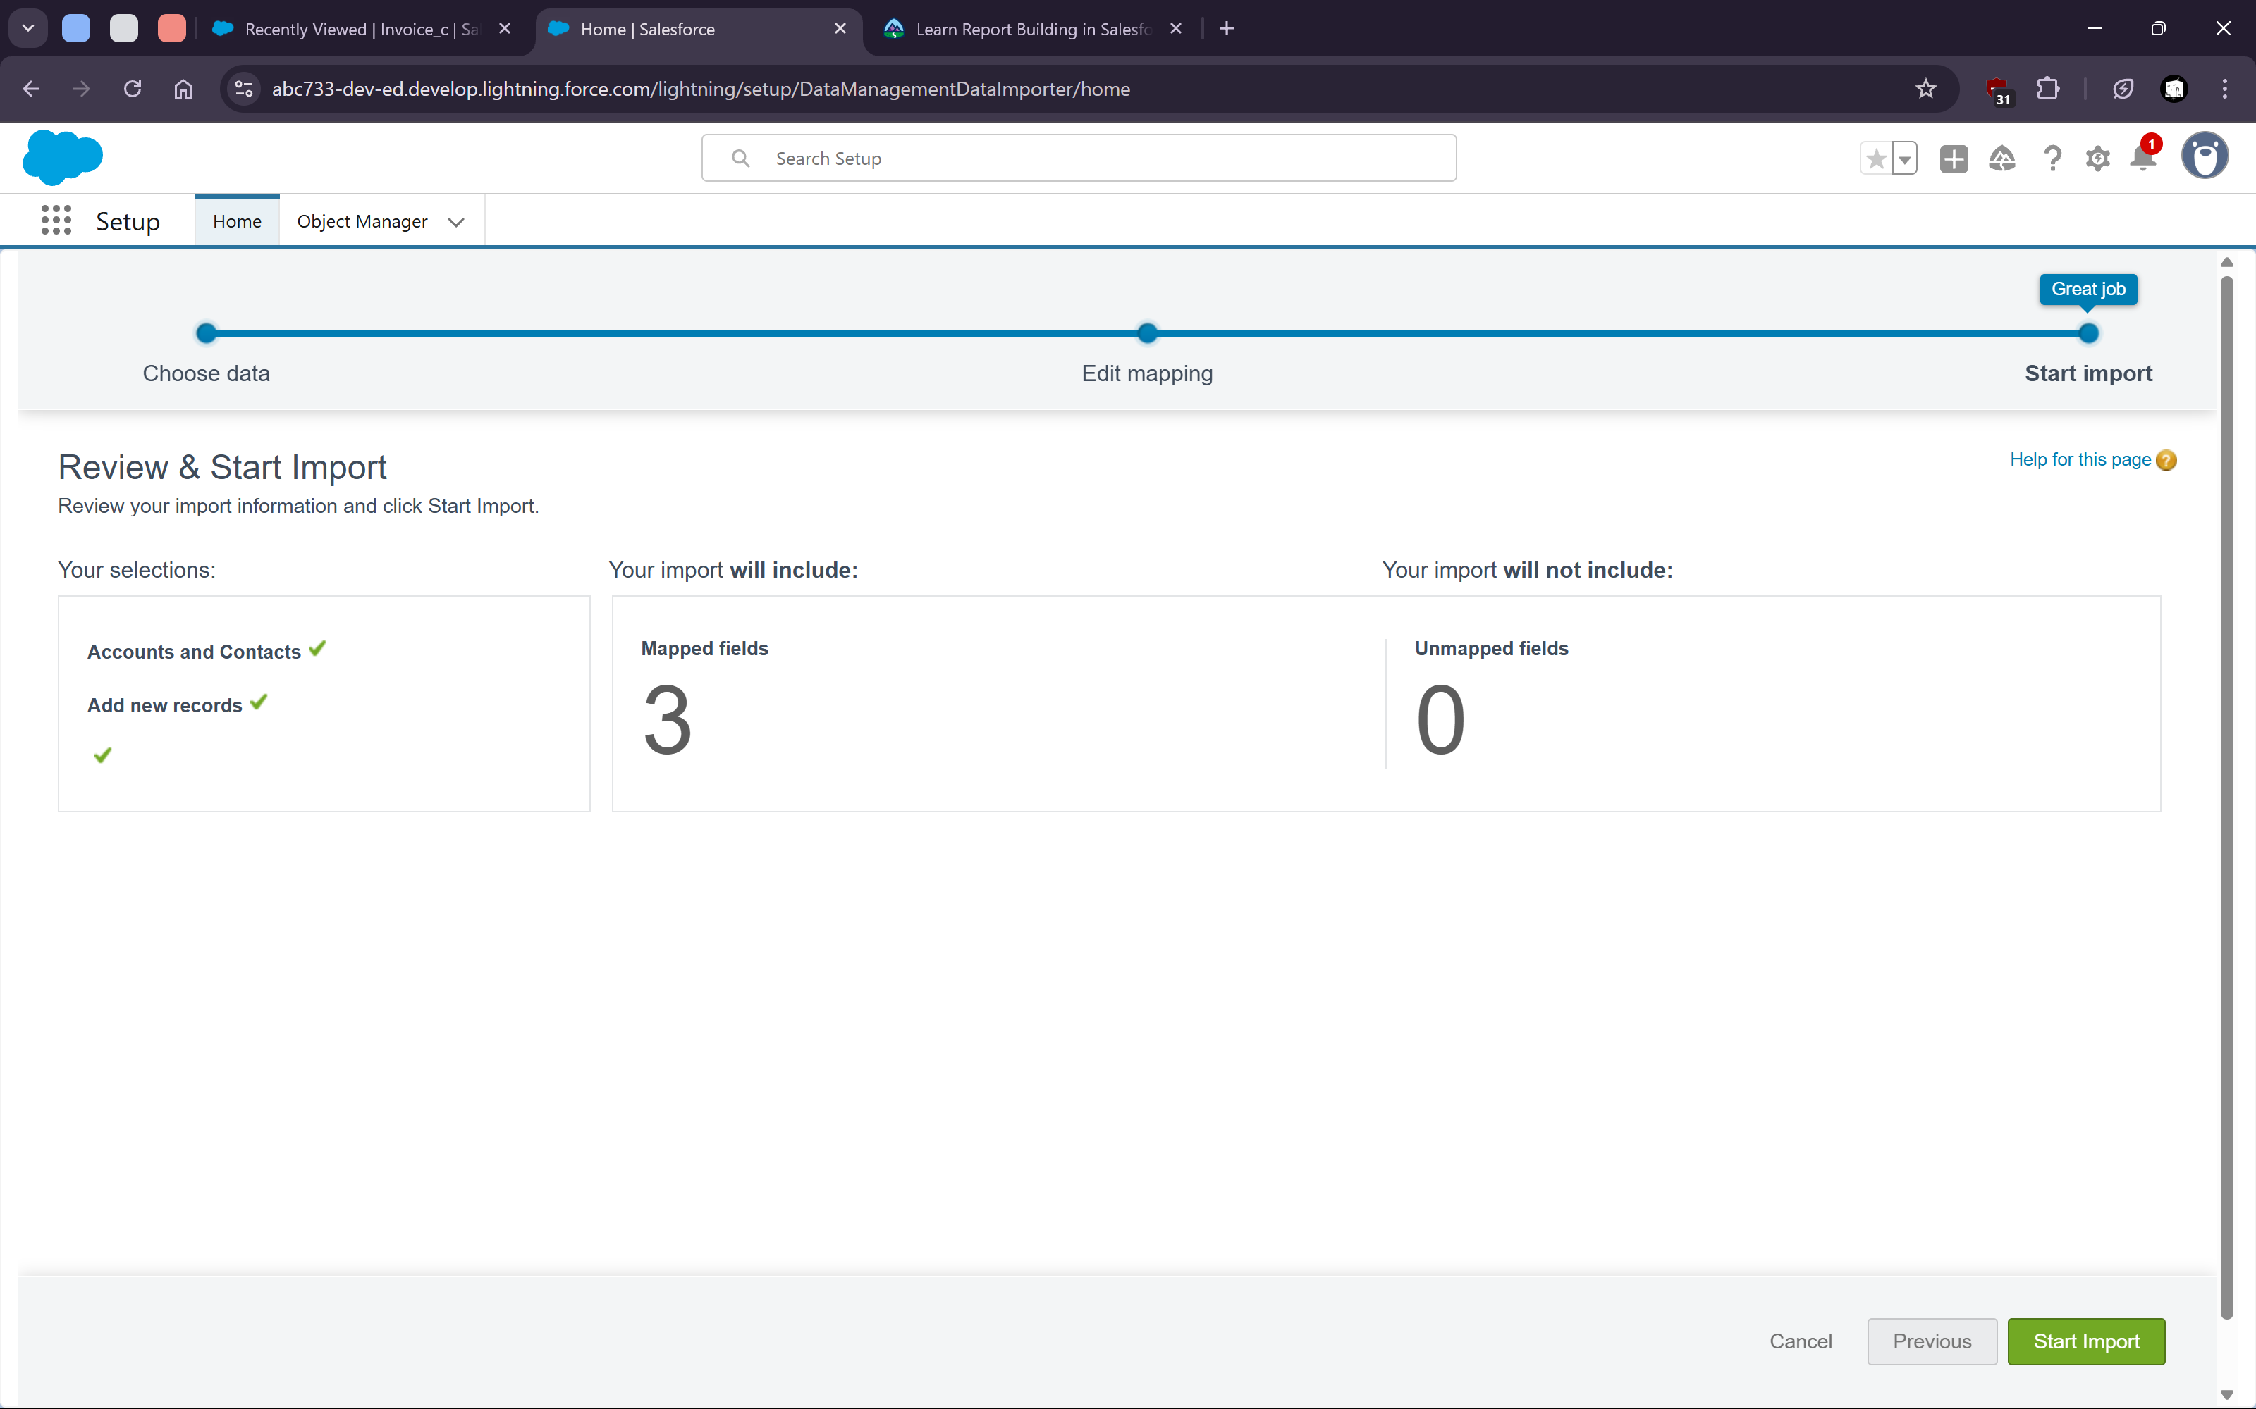


   15. Verify the imported data
   17. 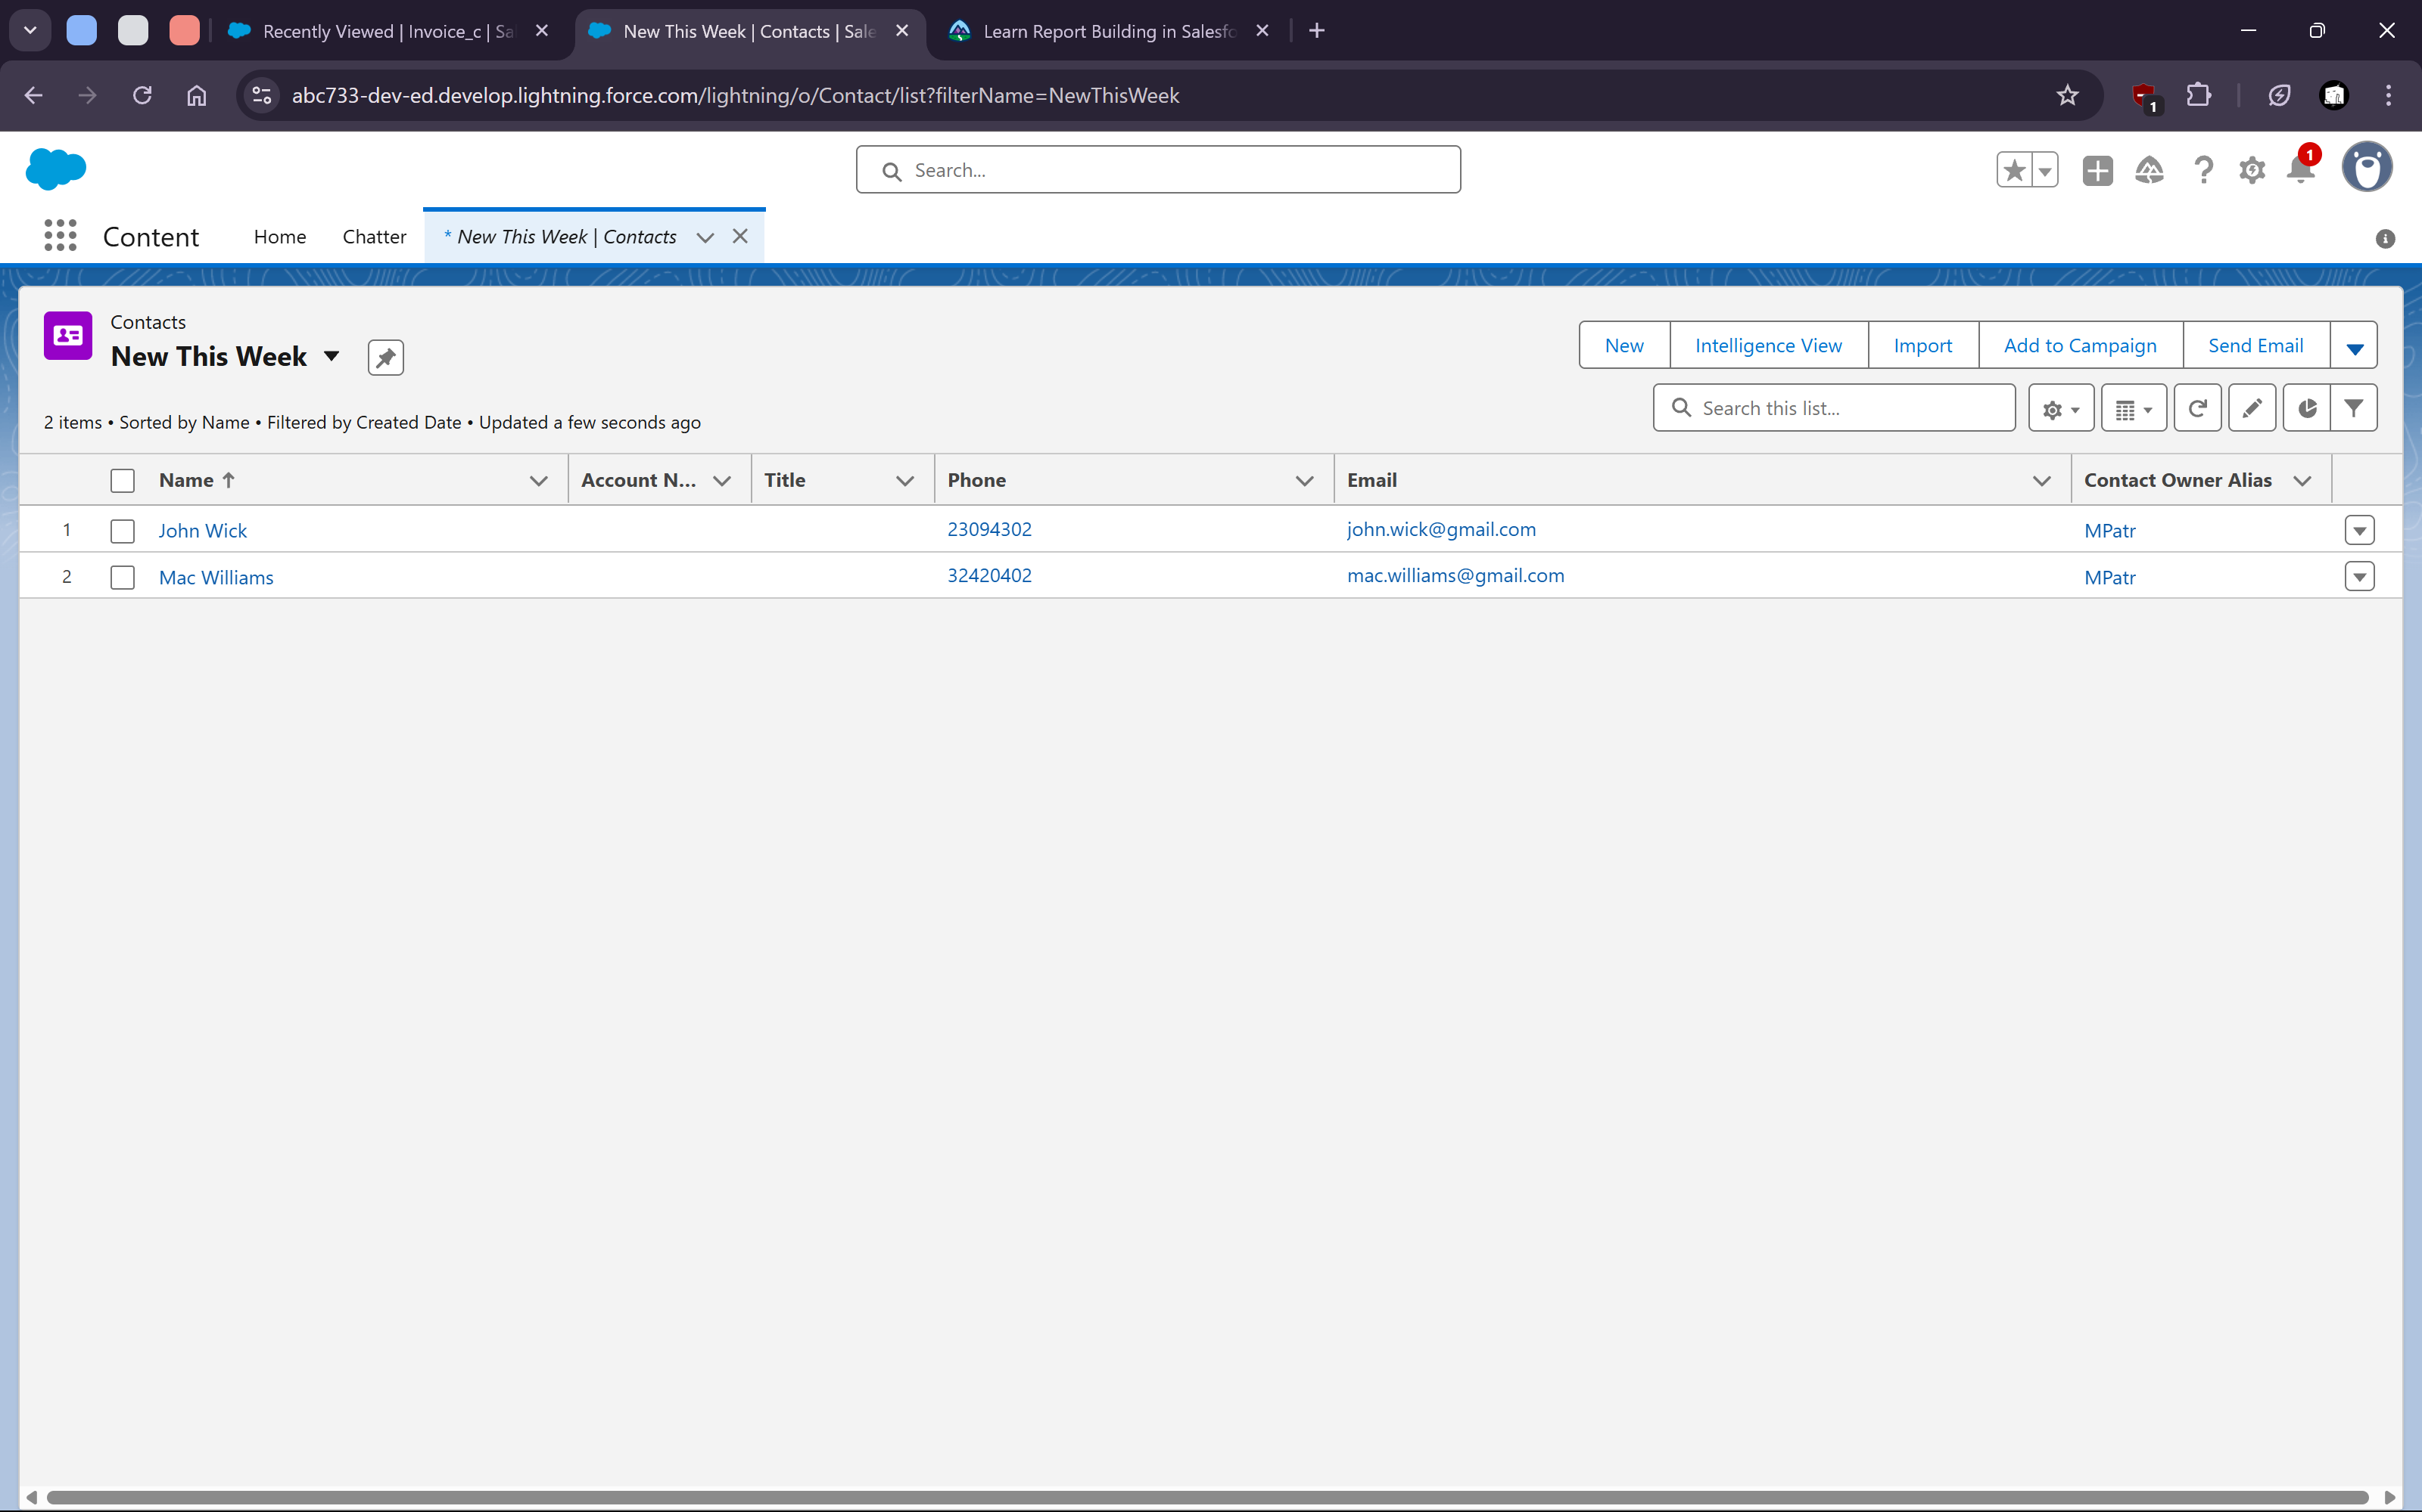
9. **Trailhead Tasks**
   1. 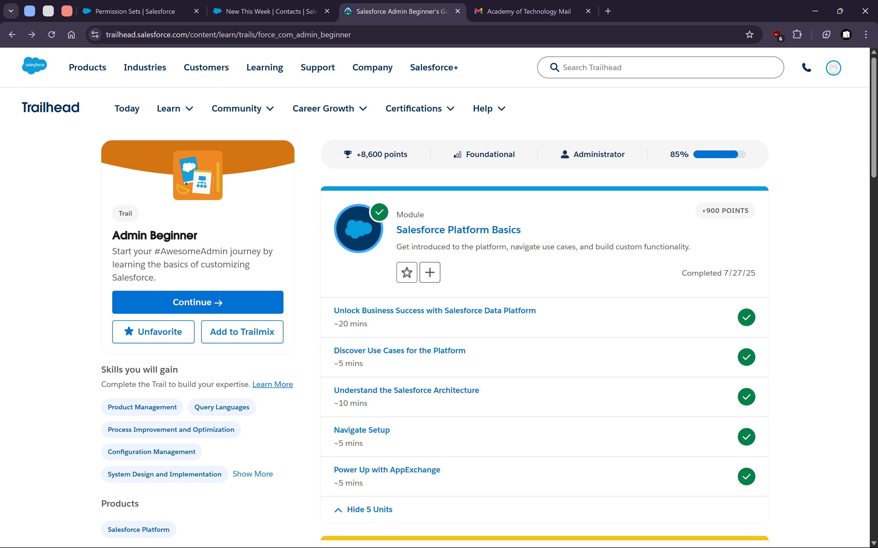
10. **Chatter**
    1. 